Wetland restoration options for the Mortlake Common Flora Reserve
A case study investigating the feasibility of restoring the
water regime of the wetland impacted by artificial drainage

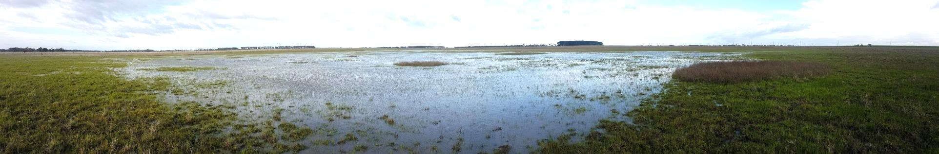
July 2016

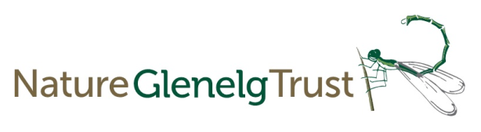
Citation: Tuck, J. & Farrington, L. (2016) Wetland restoration options for Mortlake Common Flora Reserve. Nature Glenelg Trust, Mount Gambier, South Australia

For correspondence in relation to this plan contact:
Jonathan Tuck
Project Ecologist
Nature Glenelg Trust
0402 6633 63
jonathan.tuck@natureglenelg.org.au

Acknowledgements
Sincere thanks to the following people for their assistance in compiling this plan:
- David Pitts, DELWP, Heywood
- Yvonne Ingeme, DELWP, Hamilton
- Ben Hammond & Darren Shiell, Parks Victoria, Warrnambool

This project was funded with the support of the Victorian Government

All photos by J. Tuck and L. Farrington unless otherwise credited

Table of contents
Summary and recommendations 3
1. Site details 4
1.1 Site location 5
1.2 Site history 6
1.2.1 Modification of site hydrology 6
1.3 Ecology 7
1.3.1 Geology and climate of the region 7
1.3.2 Natural features of the reserve 8
1.3.3 Native vegetation communities and flora species 8
1.3.4 Native and introduced fauna 13
1.4 The impacts of artificial drainage 13
1.5 Proposed restoration scenario 13
1.5.1 The goal of hydrological restoration 13
1.6 Impact on native vegetation 14
1.6.1 Threatened flora and fauna 14
1.7 Pre-restoration observations 15
1.7.1 Current inundation extent 15
1.7.2 Main surface inflows and outflows 15
1.8 Proposed works 15
1.9 Monitoring 18
1.10 Related hydrological restoration projects 18
2. References 19
APPENDIX A Key contacts 20

Summary and recommendations
The Mortlake Common Flora Reserve is a 304 hectare public reserve that encompasses the critically endangered Natural Temperate Grasslands of the Victorian Volcanic Plains (VVP) ecological community (EPBC Act, 1999), as well as a large (approx. 25 ha) wetland comprising Plains Grassy Wetland vegetation. Despite a past history of grazing, clearing and drainage, the reserve has managed to retain significant conservation values, including important populations of the Western Gaping Leek-orchid (Prasophyllum sp. aff. correctum) and Basalt Leek-orchid (Prasophyllum viretrum) – both listed as listed as endangered in Victoria under the DEPI Advisory List 2014.
With recent efforts at the reserve focusing on conservation of threatened species and control of invasive weeds, it is timely to look at the hydrology of the reserve as an area that can deliver significant ecological gains. There are also concerns about a long-term drying trend at wetlands in south-west Victoria, and hydrological restoration provides a way to proactively address this threat to the condition of ecological communities.
The hydrological assessment at Mortlake Common involved site visits, ground surveys using laser levels, aerial imagery acquisition, historical research, and discussions with people who have detailed knowledge of the site.
The artificial drainage carried out at the site in the past deliberately sought to limit the amount of standing water by diverting water out of the wetland, culminating in a drain that moves water to Blind Creek. This drainage has compromised the natural function of the wetland by speeding up the flow of water out of the system.
While the drainage effect is seen only when the wetland level receives solid rains, this decreased the persistence of water in the wetland later into the year, as well as limiting the extent of the wetland in higher rainfall conditions. Therefore, restoration provides a significant opportunity to transition the wetland system toward a more natural state and the associated ecological benefits.
Restoration goal
To trial and implement measures that slow down water passing through the Mortlake Common grassy wetland, and preserve and where possible enhance its ecological values.

Site details
The 304 hectare Mortlake Common Flora Reserve is situated approximately 2.5km to the north west of the Mortlake township, in south-west Victoria. The reserve was established in 1997 due to its significant vegetation values, comprising mostly of open grasslands surrounding a seasonal grassy wetland. The reserve contains the ecological community Natural Temperate Grasslands of the Victorian Volcanic Plains (VVP), listed nationally as critically endangered under the Environment Protection and Biodiversity Conservation (EPBC) Act 1999.
Due to conversion of formerly open grasslands to grazing, very few intact VVP grassland reserves in Victoria are of comparable quality and size to the Mortlake Common Flora Reserve. The few comparable examples include the Laverton North Grassland Reserve, Craigieburn Grassland Nature Conservation Reserve and Derrimut Grassland Reserve.
A major feature of the reserve is the large seasonal wetland in the north of the site, comprised of the Plains Grassy Wetland vegetation community (EVC 125). The transition from drier upslope grassland to grassy wetland offers a variety of hydrological and soil conditions that drive the flora diversity found at the site. This wetland is used by fauna including waterbirds, with records of Latham’s Snipe and nesting Brolgas, crustaceans, and amphibians including the nationally vulnerable (EPBC Act 1999) Growling Grass Frog (Litoria reniformis).
The reserve is also particularly significant owing to the presence of a number of rare and threatened species, including the only known population of the Western Gaping Leek-orchid (Prasophyllum sp. aff. correctum) and a population of the state-listed (Flora and Fauna Guarantee Act 1988) Basalt Leek-orchid (Prasophyllum viretrum).

Site location
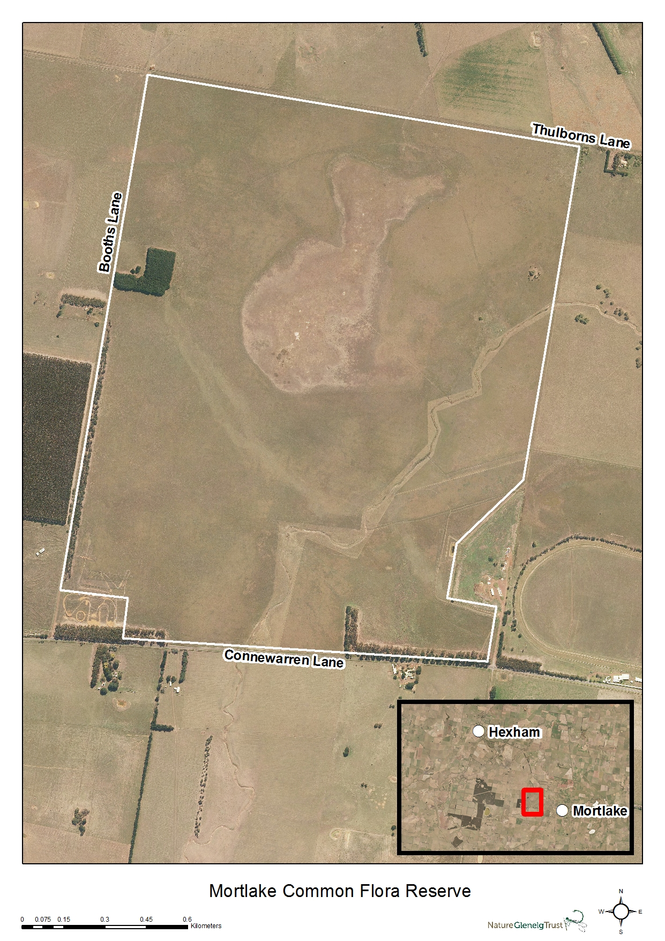
Figure 1 - Overview map of the Mortlake Common Flora Reserve

Site history
For many years, the primary land use around the reserve has been dryland pasture and other primary production. The reserve was regularly grazed in the past by landholders without large land holdings, most likely set stock with low numbers. Shire documents from 1979 indicate that on average 130 cattle were kept on the Mortlake Common along with 6-10 horses. Upon recognition for the site’s significant representation of threatened ecological communities, the Common was gazetted as a Preservation of native plants reserve’ and management responsibility was transferred to Parks Victoria in 1997. While licensed grazing ceased in 1993, an agreement with a local stock agent kept sheep on the Common until 2007, with the sheep generally removed before the autumn break and not returned until a return to dry conditions around late January (Leversha et al. 2005).

Modification of site hydrology
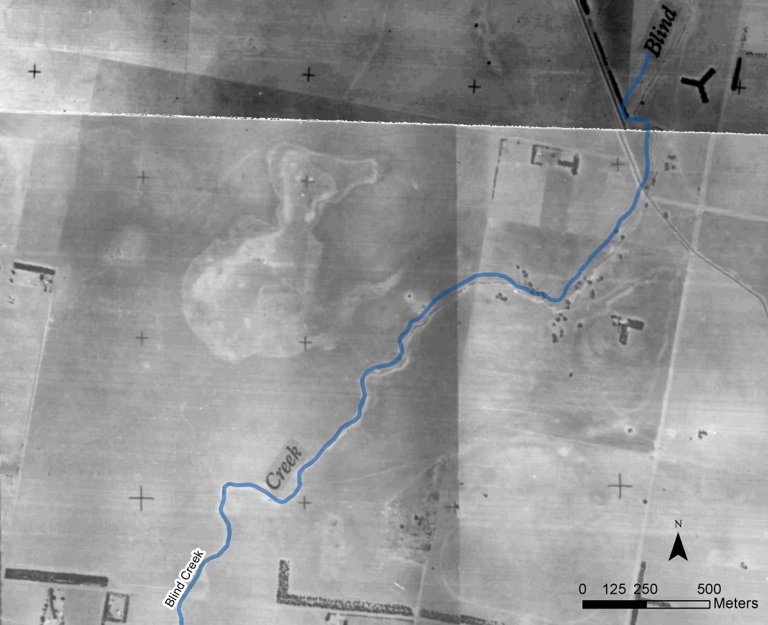
At some point prior to 1950, a shallow drain was cut through the grassy wetland, running south-east to Blind Creek which intersects the reserve. Blind Creek itself was modified (deepened) to increase its carrying capacity, and a drain was cut to run into Blind Creek from land to the east.
Figure 2 – Aerial imagery of Mortlake Common from 1950, with the
south-east drain to Blind Creek just visible

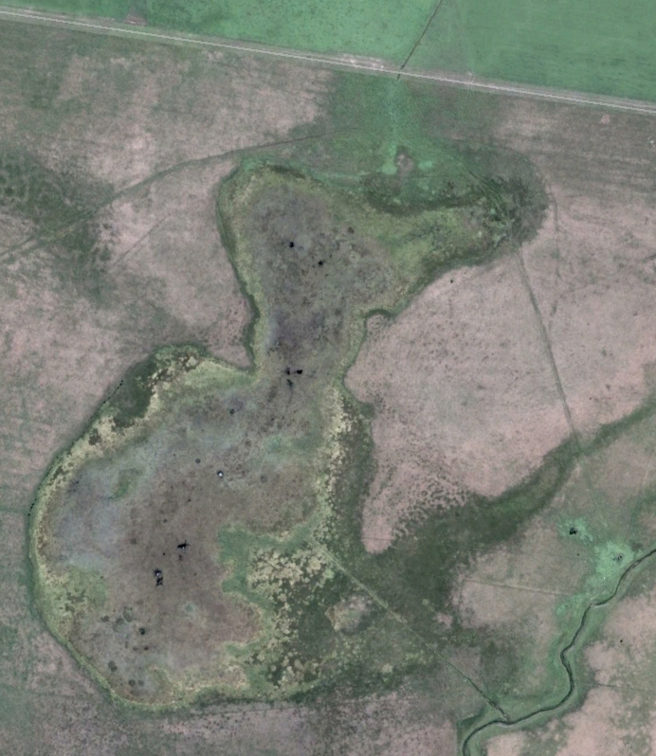
At some point after then, an additional drain was cut to aid the movement of water from the north-east of the wetland into a natural depression. Two additional drains also run in from land to the east of the reserve into Blind Creek.
Figure 3 - 2011 aerial view of the Mortlake Common wetland, with drains clearly visible running from the south-east and north-east of the wetland

Ecology

Geology and climate of the region
The geology of the region is dominated by volcanic deposits, resulting in a flat to undulating basalt plain with many rises, volcanic cones, and old lava flows and eruption points. The landscape now also features a large number of fresh or saline shallow lakes and wetlands (Department of Sustainability and Environment (DSE) 2004). Soils in the region are mostly shallow but fertile reddish-brown to black loams and clays, and support a variety of vegetation communities, including large areas of grassland, grassy woodland and wetlands.
Annual rainfall in the Mortlake area has averaged 568mm during the 20 years between 1996 and 2015, with average monthly maximum temperatures ranging from 12.9˚C in July up to 26.4˚C in February.

Natural features of the reserve
The reserve is gently undulating with the rise at the pine plantation forming the highest point at 135m AHD, and dropping approx. 10m to the lower points. Blind Creek enters the reserve on the eastern boundary and exits on the southern boundary. A depression in the mid-north of the reserve contains a seasonal grassy wetland covering approximately 25 hectares, from which the shallow drain has been dug, connecting it to Blind Creek.
Prior to drainage, the wetland would have naturally spilled over into the creek once it reached its capacity, however the current shallow drain facilitates earlier drainage and with less water retained in the system for a shorter time period. A drainage line runs in through pasture land on the northern boundary and supplies some water to the wetland.

Native vegetation communities and flora species
Mortlake Common is primarily covered by grassland, merging into a large seasonal wetland in the center of the reserve. The reserve contains one of the largest intact remnants of the nationally listed critically endangered Natural Temperate Grassland of the Victorian Volcanic Plains. The grasslands encompass Plains Grassland (EVC 132), Plains Grassy Wetland (EVC 125), and fragments of Plains Grassland/Plains Grassy Woodland Mosaic (EVC 897) Ecological Vegetation Communities (EVCs), which are listed under Victorian legislation, and shown in modeled mapping for 2005 (Figure 2).
While the reserve now consists of grassland with only one or two remnant River Red Gums (Eucalyptus camaldulensis ssp. camaldulensis), it is likely that more extensive River Red Gum woodland was once present. Demand for timber for fuel and building material would have been high after settlement, and red gums were commonly believed to compete with pasture.
A number of formal and informal flora surveys have been undertaken in the past, although none have comprehensively surveyed the entire site. Among these surveys are those by D. Tonkinson (1997), J. Morgan (1998) and K. Just (2008).

Plains Grassland community
Most of the reserve is covered by Plains Grassland (EVC 132) of varying quality. Grassland areas are particularly degraded around the boundary of the reserve, with a high density of exotic perennial grasses. However, despite the grazing history, much of the grassland areas retain significant native species diversity and some species typical of the EVC.
Flora species present include herbs such as Acaena echinata, Microseris scapigera, Convolvulus angustissimus, Eryngium ovinum, Rumex dumosus, Solenogyne dominii, Lobelia pratioides and Microtis unifolia; sedges including Schoenus apogon; small shrubs including Pimelea humilis; and a diverse range of grasses including Dichelachne crinita, Themeda triandra, Rytidosperma caespitosum, Elymus scaber and Microlaena stipoides. Trees are limited to a few scattered Acacia melanoxylon individuals.

Plains Grassy Wetland community
Also contained within the reserve is an area of Plains Grassy Wetland (EVC 125), which has been grazed in the past but retains a number of species typical of the EVC (Figure 4).
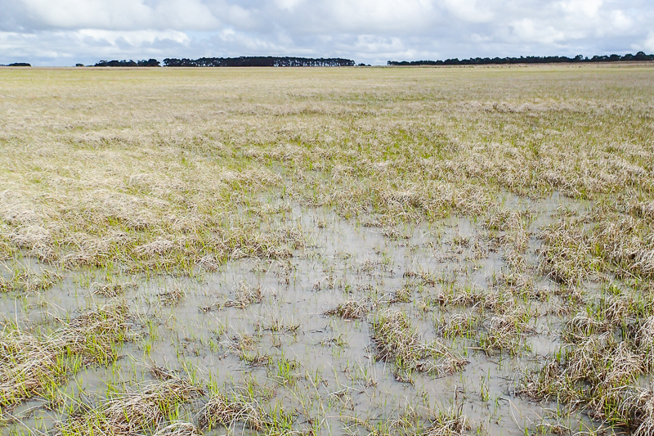
Figure 4 – Grassy wetland vegetation in a below average rainfall winter, in August 2015
Flora species present include herbs such as Coronidium gunnianum, Allittia cardiocarpa (Figure 6), Eryngium vesiculosum (Figure 7) and Lobelia pratioides; aquatic plants and sedges including Triglochin procerus, Juncus holoschoenus, Eleocharis acuta and Eleocharis pusilla; and grasses including Deyeuxia quadriseta, Glyceria australis, Poa labillardieri, Amphibromus nervosus and Austrodanthonia duttoniana. Trees and tall shrubs are limited to sparse Ozothamnus ferrugineus (Figure 5) on the wetland fringe, and a sparse stand of regenerating Eucalyptus camaldulensis ssp. camaldulensis at the south east of the wetland, as well as some planted individuals on the western edge. More trees likely existed before clearance.
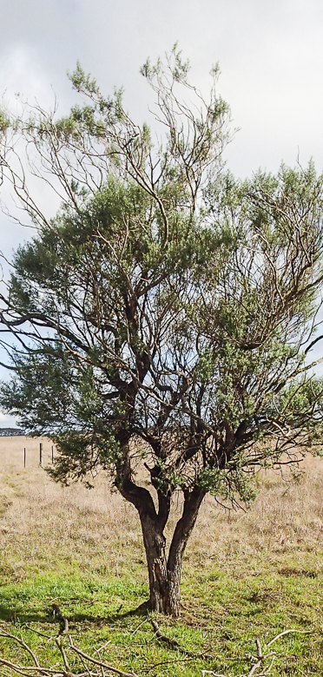  Figure 5 – Tree Everlasting (Ozothamnus ferrugineus) on the wetland fringe | 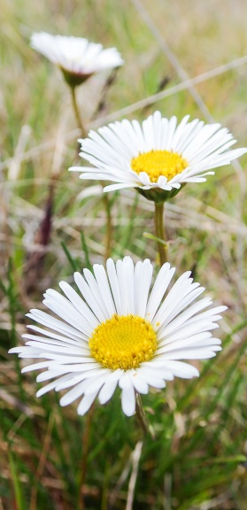  Figure 6 – Swamp Daisy (Allittia cardiocarpa) | Figure 7 – Prickfoot (Eryngium vesiculosum)

Other native flora communities
Small patches of Plains Grassland/Plains Grassy Woodland Mosaic (EVC 897) are also modeled to occur on the northern fringe of the wetland.

Rare and threatened flora
The reserve contains significant rare and threatened flora, including the Plains Yam Daisy (Microseris scapigera), Arching Flax-lily (Dianella sp. aff. longifolia (Benambra)) and Pale Swamp Everlasting (Coronidium gunnianum).
Scientific name | Common name | Conservation status
Coronidium gunnianum | Pale Swamp Everlasting | Vulnerable
Dianella sp. aff. longifolia (Benambra)) | Arching Flax-lily | Vulnerable
Microseris scapigera | Plains Yam Daisy | Vulnerable
Prasophyllum sp. aff correctum (Mortlake) | Western Gaping Leek-orchid | Endangered

A number of Leek-orchid populations exist within the reserve, including the Basalt Leek-orchid (Prasophyllum viretrum) and a population of the currently undescribed Western Gaping Leek-orchid (Prasophyllum sp. aff. correctum) – of which this is the only known population. The original population estimate of the Western Gaping Leek-orchid was 7000 plants in 2006 (observer Kate Vlcek, DSE), while approximately fifty plants were seen by Karl Just in December 2008, and less than 100 by David Pitts (DSE) in 2010-11.

Pre-European flora communities
Other vegetation communities were potentially present before the European settlement of the area. DSE modeling (2005 – see Figure 9) of pre-European vegetation classes suggests that while the site was dominated by Plains Grassland and Plains Grassy Wetland, there was likely some Plains Grassy Woodland (EVC 55) on the western and northern boundaries, and in the south eastern corner.
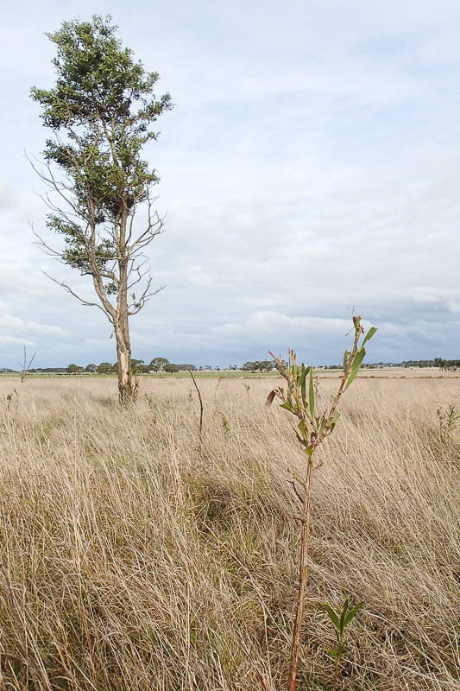
Figure 8 – Regenerating Blackwoods (Acacia melanoxylon)
in the north of the reserve

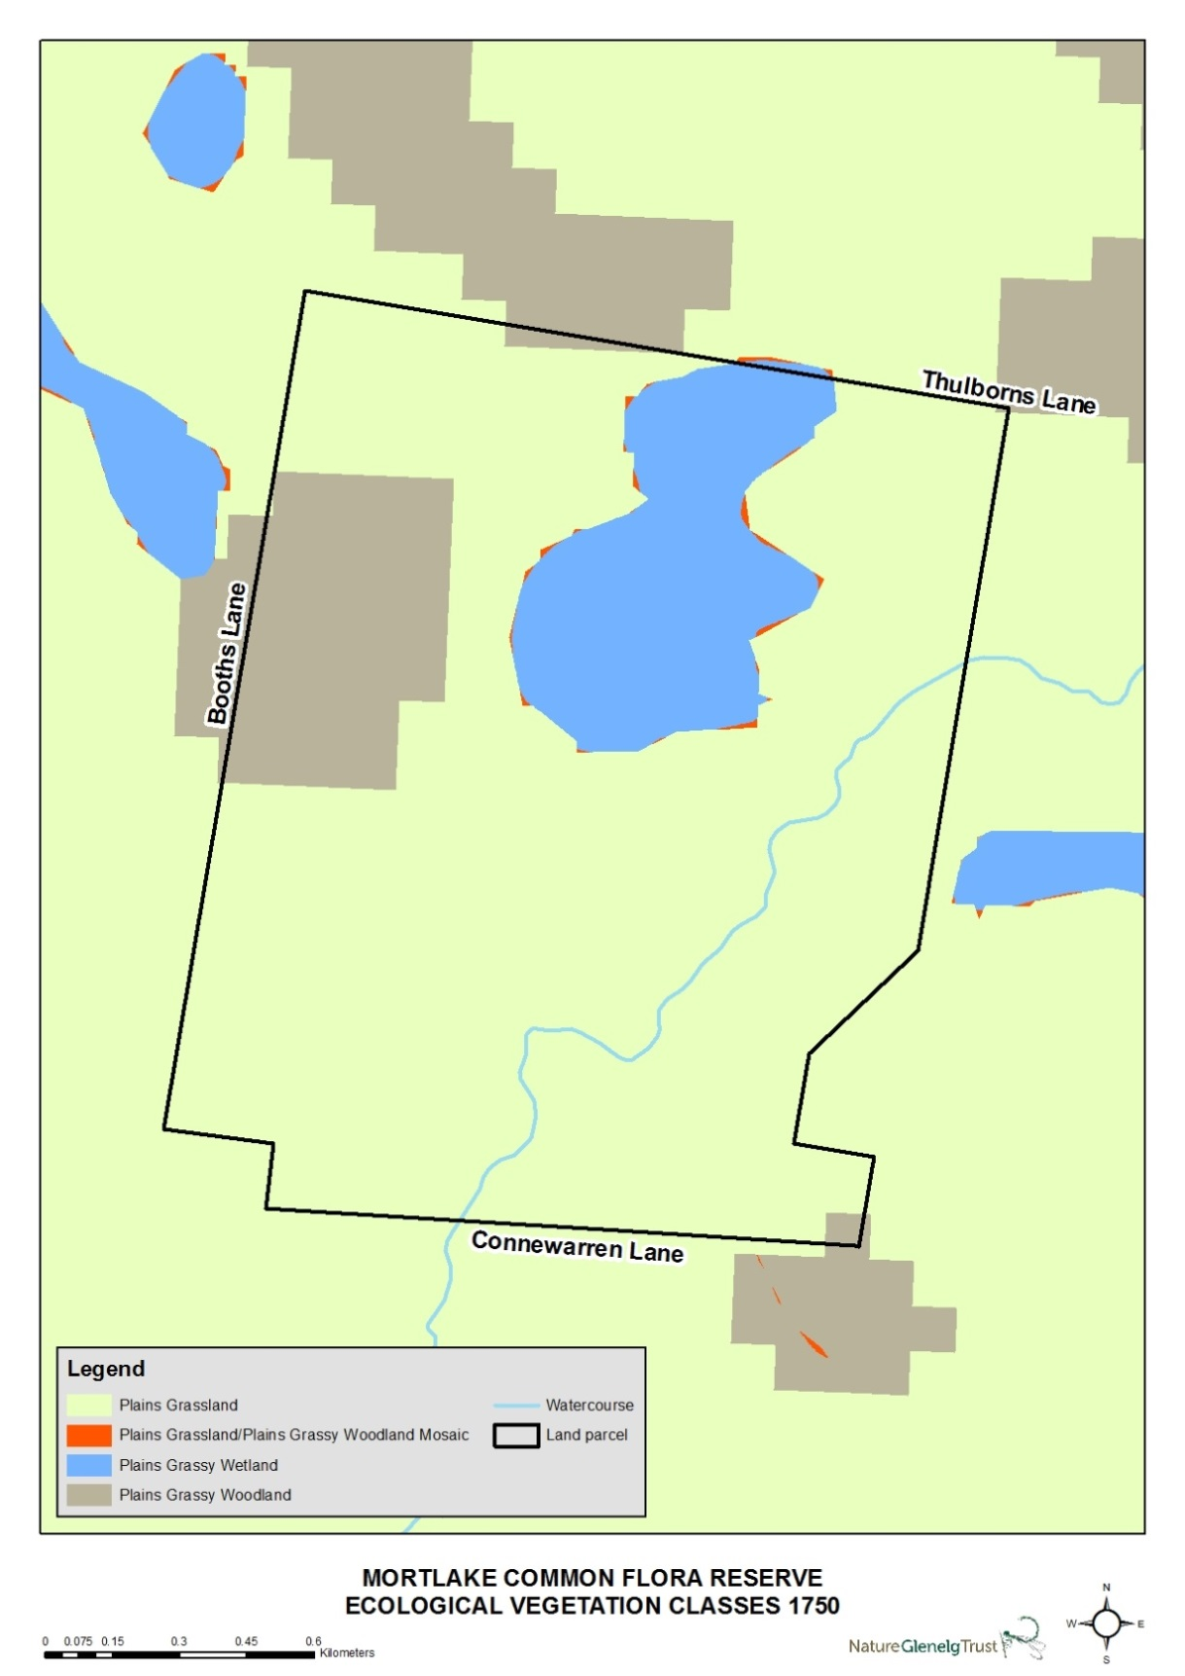
Figure 9 - Map of modelled 1750 EVCs

Native and introduced fauna
Comprehensive fauna monitoring has not been undertaken at the reserve, but some of the native species observed have included birds such as the Brolga (Grus rubicunda), Whiskered Tern (Chlidonias hybridus javanicus), Latham’s Snipe (Gallinago hardwickii), White-faced Heron (Egretta novaehollandiae) and Wedge-tailed Eagle (Aquila audax); crustaceans including the regionally vulnerable Hairy Burrowing Crayfish (Engaeus sericatus); frogs including the Spotted Marsh Frog (Limnodynastes tasmaniensis), Common Froglet (Crinia signifera) Southern Brown Tree Frog (Litoria ewingii), and the endangered (Vic) Growling Grass Frog (Litoria raniformis); and reptiles including the Lowland Copperhead (Austrelaps superbus) and the Tussock Skink (Pseudemoia pagenstecheri).
Small native mammals may also be present in the grassland, but a survey targeting these species is yet to occur. Introduced mammal species observed at the reserve include Fallow Deer (Dama dama), Red Fox (Vulpes vulpes), European Hare (Lepus europaeus), Rabbit (Oryctolagus cuniculus), House Mouse (Mus musculus) and Cat (Felis catus).

The impacts of artificial drainage
Drainage at Mortlake Common has been limited to the cutting of shallow channels, which have still allowed some water to accumulate in the main wetland.
However, under higher wetland levels these channels drain water from the wetland, as well as reducing soil moisture to the east and south of the site. These have decreased the duration of inundation.
At the creek/drain interface, the drainage channel cut through the higher bank of the creek has given an opportunity for invasive Spiny Rush to move along the drain and toward the wetland system. Recent weed control has reduced this threat in the drain itself, but it remains a significant risk to the vegetation communities in the wetland and the site as a whole.

Proposed restoration scenario

The goal of hydrological restoration
Past drainage at Mortlake Common favoured agriculture over ecological communities by acting to dry out the swamp, and the goal of restoration should be the reverse.
Restoration goal:
To trial and implement measures that slow down water passing through the Mortlake Common grassy wetland, and preserve and where possible enhance its ecological values.
In achieving this goal, the project should aim to:
- Increase soil moisture duration at the site.
- Utilise methods that cause the lowest possible disturbance to the site.
- Cause a positive shift in chosen biological and/or hydrological indicators, as measured during pre- and post-restoration ecological monitoring.
- Where possible, also consider restoration methods capable of involving interest groups and the wider community in the works.
The proposed restoration scenario will raise the level of the wetland in a wet year, allowing for a more natural flow path out to Blind Creek. This will go some way to restoring the natural wetting and drying cycle of the wetland.

Impact on native vegetation
The primary impact of hydrological restoration on most of the wetland vegetation will be through increased duration of saturation, which will make water available later in the draw-down stage of the wetland lifecycle. In addition, there will also be a small increase in wetland extent as water levels rise above the level currently regulated by the artificial drain.

Threatened flora and fauna
Hydrology is a major driver of habitat suitability for flora and fauna, and it is important to recognise the potential for a change in the hydrological regime at the reserve to cause changes in habitat.
As the artificial drain only operates at higher wetland levels, it is unlikely that restoration will result in significant changes in depth to the wetland. Across the wetland and current wetland edge, there is a dominance of inundation-tolerant species which are adapted to the range of moisture conditions experienced across seasons and across years of varying climatic conditions, and the likelihood of negative impacts is relatively low.
However, there is the potential for species on the wetland edge which have not previously been subject to inundation to be inundated after restoration.
For this reason, it is proposed that any restoration measures follow monitoring in late 2016 to determine the extent and location of threatened flora late in 2016. In particular, Prasophyllum sp. aff. correctum has not been observed at the reserve for at least the last 3 years, but it is anticipated that the return to wetter conditions in 2016 should give a good opportunity for a targeted search later in the year. If the orchid is found to occur in the impact zone, this will need to be incorporated into restoration planning.

Similarly, other threatened flora populations could be included in the same survey, including Prasophyllum viretrum, Pimelea curviflora, Dianella sp. aff. longifolia (Benambra) and Microseris scapigera.

Pre-restoration observations

Current inundation extent
High rainfall in June and July of 2016 has allowed on-ground verification of current inundation extent (Figure 10).
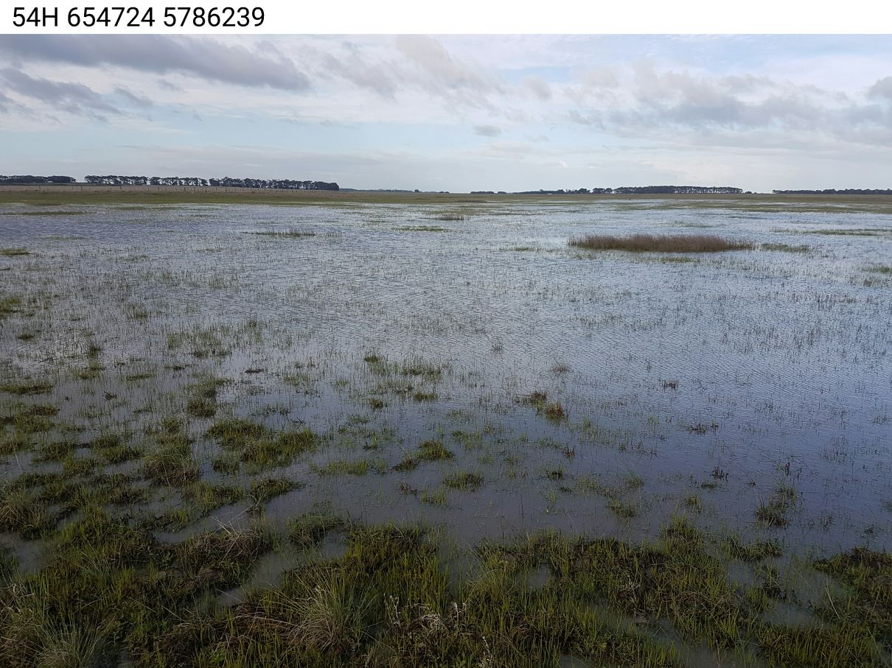
Figure 10 - Main wetland after high rainfall in July 2016

Main surface inflows and outflows
Aside from direct rainfall, the major inflow into the wetland system is via a drainage line that runs south through the property into the reserve.

Proposed works
To obtain the required blocking of flow through drains, the restoration design uses sandbag structures at strategic locations to block the course of water and restore a more natural hydrological regime (Figure 11). These simple structures consist of a number of sandbags placed across the drain and wrapped in a geo-textile material.
Sandbag structures have a number of advantages over permanent structures that make them appropriate for this type of restoration. They are low cost, easy to transport on a light and low-impact vehicle, simple to install, and easily modifiable to adjust sill height and therefore water level. Also significant is that while they can last for 10 or more years – particularly in low flow environments – they are impermanent and uniquely suited to a restoration trial.
Sandbag structures have been successfully installed during wetland restoration trials at a number of sites in south-west Victoria, including wetlands at Long Swamp, Gooseneck Swamp and Cashmore. Following positive results and discussion with land managers, some of these structures have been converted to permanent earthen banks where deemed appropriate.
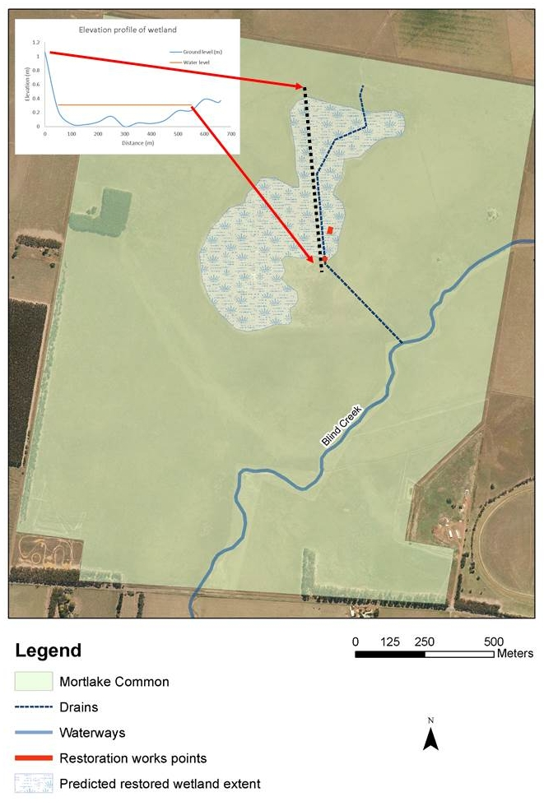
Figure 11 – Proposed wetland restoration scenario

Monitoring
As well as delivering on-ground work, a number of indicators should be monitored both before and after restoration works. Monitoring will allow the trajectory of change to be tracked to ensure it remains aligned with the ecological objectives for the site.
Prior to restoration, monitoring should provide a detailed survey of wetland and near-wetland habitat, to assess any other populations that could be affected.
Suggested monitoring requirements are:
- Installation of a surface water level gauge board and level logger in the wetland to verify water levels. This should be complemented by on-ground verification of inundation extent.
- Establishment of at least one long-term photopoint at a key location, such as near the proposed trial restoration structure.
- Establishment of permanent replicate flora quadrats baseline monitoring to record the position of dominant species within the wetland, including across different zones of hydrological influence.
- Seasonal aquatic fauna surveys, including frogs and crustaceans.

Related hydrological restoration projects
Nature Glenelg Trust has implemented a number of successful hydrological restoration projects on public and private land; more details on these projects can be found at the following links:
http://natureglenelg.org.au/current%20projects/restoration-trial-at-gooseneck-swamp-grampians-national-park
http://natureglenelg.org.au/current%20projects/wetland-restoration-on-private-land

References
Department of Environment and Primary Industries (DEPI) (2014). Advisory list of rare or threatened plants in Victoria - 2014. Department of Sustainability and Environment, Victoria.
Department of Sustainability and Environment (DSE) (2004). Ecological Vegetation Class benchmarks. Department of Sustainability and Environment, Victoria.
Leversha, J., Gowans, S. & Milne, R. (2005). Victorian Volcanic Plains grasslands Glenelg Hopkins study – The role of disturbance regimes in maintaining biodiversity. Centre for Environmental Management, University of Ballarat. Report to Parks Victoria.

Key contacts
Jonathan Tuck – Project Ecologist, Nature Glenelg Trust, Mount Gambier
jonathan.tuck@natureglenelg.org.au
Lachlan Farrington – Wetland and Landscape Ecologist, Nature Glenelg Trust, Warrnambool
lachlan.farrington@natureglenelg.org.au
Ben Hammond – Ranger Team Leader – Shipwreck Coast and Hinterland Area, DELWP, Warrnambool

