REVIEW AND REVISION OF THE
SOUTHERN BROWN BANDICOOT
(Isoodon obesulus)
REGIONAL ACTION PLAN FOR THE SOUTH EAST OF SOUTH AUSTRALIA: 2017-2027
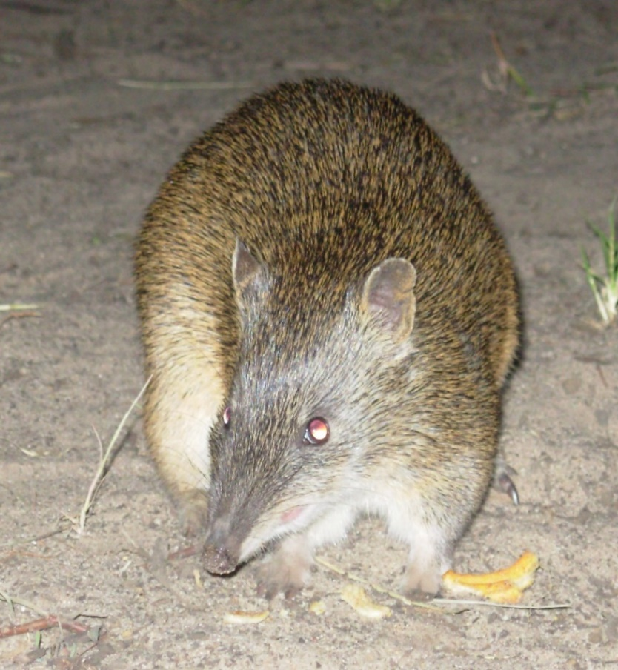

Bryan T. Haywood
July 2017

Report to the Department of Environment, Water and Natural Resources

Citation
Haywood, B. T. (2017). Review and revision of the Southern Brown Bandicoot (Isoodon obesulus) Regional Action Plan for the South East of South Australia: 2017-2027. Report to Department of Environment, Water and Natural Resources, Government of South Australia. Nature Glenelg Trust, Mount Gambier, South Australia.

For correspondence in relation to this report contact:
Mr Bryan Haywood
Senior Ecologist
Nature Glenelg Trust
0427 001 853
bryan.haywood@natureglenelg.org.au

Cover photo
Southern Brown Bandicoot observed foraging in open ground on sandy soil in western Victoria.

All photos taken by Bryan Haywood unless otherwise stated.

Disclaimer
This report forms part of the Restoring Under-represented Ecological Communities project commissioned by the Department of Environment, Water and Natural Resources. Although all efforts were made to ensure quality, it was based on the best information available at the time and no warranty express or implied is provided for any errors or omissions, nor in the event of its use for any other purposes or by any other parties.

ACKNOWLEDGEMENTS
The Restoring Under-represented Ecological Communities project was funded by the Australian Government’s Caring for our Country Program, through a regional allocation of grant funding to the South East Natural Resources Management Board.
Nature Glenelg Trust delivers this program on behalf of Natural Resources South East, and thanks their staff (Melissa Herpich, Nick McIntyre and Melissa Hunter) for the support received throughout the project.
Special additional thanks to:
- Dan Harley (formerly DEH) for producing the original regional action plan for Southern Brown Bandicoots in the South East of SA.
- Mark Bachmann for editorial assistance, photographs and data on Southern Brown Bandicoot captures.
- Andrea Fullagar for her efforts with the 2016 digging abundance monitoring.
- Rosey Pounsett, Sue Black, David Pitts, Justin Cook, Troy Horn and Abigail Goodman for participation in the May 2017 workshop.
- Rose Thompson and Sam Rothe for researching and editing previous versions of this RAP.
- Rebecca Sheldon for completing an editorial review of Regional Action Plans, prior to their completion.

List of abbreviations
BDBSA | Biological Database of South Australia
BOM | Australian Bureau of Meteorology
DEWNR | South Australian Department of Environment, Water and Natural Resources
DELWP | Victorian Department of Environment, Land, Water and Planning
FSA | ForestrySA
ha | Hectare
NGT | Nature Glenelg Trust
NRSE | Natural Resources South East
NRM | Natural Resource Management
OFO | OneFortyOne Plantations
RP | Recovery Plan
SA | South Australia
SE SA | the South East of South Australia

CONTENTS
List of Figures v
List of Tables v
1 INTRODUCTION 1
1.1. The role of Regional Action Plans for the recovery of species and ecological communities in the South East of South Australia 1
1.2 Background to the Southern Brown Bandicoot Regional Action Plan 3
1.2.1 Purpose 4
1.2.2 Scope 5
1.3 RAP review and revision process 5
2 SOUTHERN BROWN BANDICOOT IN SOUTH EAST SA 6
2.1 Distribution 6
2.2 Behaviour 7
2.3 Diet 7
2.4 Reproduction 8
2.5 Nesting 8
2.6 Critical threats 8
2.7 Current status 9
2.8 Conservation effort towards Southern Brown Bandicoot recovery in the South East (pre 2006) 9
3 EXISTING ACTION PLANS 11
3.1 National and state plans 11
3.2 South East Regional Action Plan 12
4 REVIEW OF THE SOUTH EAST REGIONAL ACTION PLAN 13
4.1 Achievements against the South East Regional Action Plan 13
4.2 Summary of achievements and gap analysis 38
5 REVISED SOUTH EAST REGIONAL ACTION PLAN 41
5.1 Goal and objectives 41
5.2 Revised actions 2017 to 2027 41
6 REFERENCES 50
APPENDIX 1 - Workshop participants 54
APPENDIX 2 - Digging abundance survey methodology (extract from Bachmann & Fullagar, 2017) 55
APPENDIX 3 - Review summary 57

List of Figures
Figure 1: Southern Brown Bandicoot (Source: Mark Bachmann) 6
Figure 2: Digging in sand and terra rossa soils (Source: Mark Bachmann) 7
Figure 3: Peter Spinks Community Programs Coordinator (left) and Jim O’Hehir, ForestrySA (right) at Newbery Park PS nursery, 2009. 15
Figure 4: Dry Creek to Honeysuckle biodiversity corridor 17
Figure 5: Gower to Windy Hill biodiversity corridor 18
Figure 6: Honan to Woolwash biodiversity corridor 19
Figure 7: Example of track rationalisation in Marshes NFR (2010 compared to 2017) 20
Figure 8: Patches of Eucalyptus woodland south-west of Lucindale and the site of the hair tube record. 23
Figure 9: Example of a NFR management plan map showing compartments reserved from burning. 26
Figure 10: NFR Scientific Reference Area burn history (from 2006 to 2016), incl. presence/absence of SBB in 2016. 28
Figure 11: Female Southern Brown Bandicoot with ear biopsy taken from right ear. Source: ForestrySA (2007) 30
Figure 12: Conservation and Land Management students from SE TAFE setting up a trapping line in Kangaroo Flat NFR in 2007, with assistance from Rob Mengler (FSA) (Source: ForestrySA). 31
Figure 13: Southern Brown Bandicoot pouch young from one of the breeding females caught during the ForestrySA survey in 2007 (Source: ForestrySA). 31

List of Tables
Table 1: Example of NFR compartment weed treatments for the period 2006-16 (source: ForestrySA) 14
Table 2: Sites where Southern Brown Bandicoots have been known to occur since 1990 22
Table 3: Caroline Forest NFRs and monitoring results for Southern Brown Bandicoots 1998-2016 (Source: Bachmann & Fullagar, 2017). 24
Table 4: Nangwarry Forest NFRs and monitoring results for Southern Brown Bandicoots 1998-2016 (Source: Bachmann & Fullagar, 2017). 25
Table 5: Fire history of Scientific Reference Areas in NFRs (and other patches) including presence/absence of Southern Brown Bandicoots in 2016 27
Table 6: Patches where Southern Brown Bandicoots were not detected in 2004 and monitoring results for 1998-2016 (Source: Bachmann & Fullagar, 2017). 29
Table 7: Summary of key habitat patches within core Southern Brown Bandicoot populations. 30
Table 8: Summary of Southern Brown Bandicoot captures and ear biopsies provided to genetic studies from 2001-2007 33

INTRODUCTION
  - The role of Regional Action Plans for the recovery of species and ecological communities in the South East of South Australia
The first Threatened Species and Habitat Recovery Program in the South East (SE) of South Australia (SA) commenced in 2003 and was delivered through the Department of Environment, Water and Natural Resources (DEWNR, and its predecessors). The Program resulted in a comprehensive assessment of the extent and conservation status of a wide range of threatened species and ecological communities, initially prioritising those with a national listing. Given the focus of the Program on threat abatement, a key output also included the development of an associated habitat assessment tool for prioritising on-ground works (called EWeedMAT; see Herpich & Lindsay 2008). Many of the target species under that Program were already the subject of National Recovery Plans (NRPs). Given their national scale, these documents often only capture broad-scale distribution and population data, and document threats and outline conservation strategies at that scale. As a result, with the notable exception of species restricted to very small geographic areas, NRPs – while an important tool for setting out high level conservation strategies for the species or community – are often less instructive or meaningful for implementation at the regional or local scale. Notably, this is the scale at which on-ground action must be delivered for effective recovery.
The original purpose of developing Regional Action Plans (RAPs) for target species and communities in SE SA was to draw upon the guidance of NRPs (where they existed), in combination with local data and expertise, to identify critical knowledge gaps and devise recovery actions suitable for implementation at the regional scale. The threatened (or regionally significant) species and ecological communities with RAPs prepared or updated (note multiple references) prior to 2016 included:
Fauna
Birds
- Bush Stone-curlew, Burhinus grallarius (Harley et al. 2005)
- Malleefowl, Leipoa ocellata (Harley 2006; Harley & Le Duff 2009)
- Orange-bellied Parrot, Neophema chrysogaster (Harley et al. 2005)
Reptiles
- Striped Legless Lizard, Delma impar (Harley et al. 2005)
Amphibians
- Southern Bell Frog, Litoria raniformis (Harley et al. 2005)
Mammals
- Southern Brown Bandicoot, Isoodon obesulus (Harley 2006)
- Southern Bent-wing Bat, Miniopterus schreibersii bassanii (Kerr & Bonifacio 2009)
- Heath Mouse, Pseudomys shortridgei (Harley et al. 2005)
- Long-nosed Potoroo, Potorous tridactylus (Harley et al. 2005)
Invertebrates
- Glenelg Spiny Freshwater Crayfish, Euastacus bispinosus (Sweeney & Dickson 2011)
Fish
- Drought Response Plan for Threatened Native Freshwater Fish (Slater & Hammer 2009)
Flora
- Sticky Wattle, Acacia dodonaeifolia (Johnson 2005b)
- Jumping Jack Wattle, Acacia enterocarpa (Johnson 2005a, 2005b; Johnson & Dickson 2009)
- Hairy-pod Wattle, Acacia glandulicarpa (Johnson 2005b)
- Three-nerve Wattle, Acacia trineura (Johnson 2005b)
- Avenue Cassinia, Cassinia tegulata (Johnson 2005a; Johnson & Dickson 2009)
- Clover Glycene, Glycine latrobeana (Hinchliffe 2007)
- Sand Ixodia, Ixodia achillaeoides ssp. arenicola (Johnson 2005a; Fearn & Johnson 2010)
- Silver Daisy-bush, Olearia pannosa spp. Pannosa (Johnson 2005a; Johnson 2005b)
- Maroon Leek-orchid, Prasophyllum frenchii (Dickson & Rajic 2009)
- Monarto Mint-bush, Prostanthera eurybioides (Johnson 2005a; Johnson & Dickson 2009)
- Pink Mulla Mulla, Ptilotus exaltatus (Johnson 2005b)
- Golden Billy-buttons, Pycnosorus chrysantes (Johnson 2005b)
- Large-fruited Grounsel, Senecio macrocarpus (Hinchliffe 2007)
- Leafy Templetonia, Templetonia stenophylla (Johnson 2005b)
Ecological Communities
- Buloke, Allocasuarina luehmannii, Woodland (Johnson 2005; Johnson & Fearn 2009)
- Grey box, Eucalyptus microcarpa, Grassy Woodland (Johnson 2005; Johnson & Fearn 2009)

The review and revision of the Southern Brown Bandicoot RAP builds on previous action planning, and forms part of a larger project - Restoring the Under-represented Ecological Communities of the South East (RUEC) project, which is funded by the Australian Government, National Landcare Programme. Nature Glenelg Trust is delivering the program from 2014-2018 on behalf of DEWNR (Natural Resources South East - NRSE).
The RAPs that have been, or will be, developed or revised during this period include:

Regional Action Plans
- Malleefowl, Leipoa ocellata
- Southern Brown Bandicoot, Isoodon obesulus
- Sthn Bent-wing Bat, Miniopterus orianae bassanii
- Heath Mouse, Pseudomys shortridgei
- SA Blue Gum, Eucalyptus leucoxylon, Woodland
- Swamp Gum, Eucalyptus ovata, Woodland
- Karst Rising Springs Ecological Community
Translocation Plans
- Trailing Hopbush, Dodonaea procumbens
- Avenue Cassinia, Cassinia tegulata
- Elegant Spider-orchid, Caladenia formosa
- Little Dip Spider-orchid, Caladenia richardsiorum
- Maroon Leek-orchid, Prasophyllum frenchii
- Swamp Greenhood, Pterostylis tenuissima
- Metallic Sun-orchid, Thelymitra epipactoides

1.2 Background to the Southern Brown Bandicoot Regional Action Plan
This is the second version of a Southern Brown Bandicoot RAP for the SE region. For the purposes of this document, the SE region of SA is defined by the region’s Natural Resources Management (NRM) Plan (SENRM Board 2010). The NRM Plan delineates the SENRM region boundary and provides an overview of the region and its natural resources.
Background information on the biology and ecology of the Southern Brown Bandicoot is presented in the original Southern Brown Bandicoot RAP (Harley 2006), with only minor sections reproduced here. Importantly this information aligns with the draft National Recovery Plan for the Southern Brown Bandicoot (Brown and Main 2010), and the Action Plan for Australian Mammals 2012 (Woinarski et al. 2014). Threatening processes outlined in the original RAP, remain relevant and align with the national conservation advice for the species issued under the Environment Protection and Biodiversity Conservation (EPBC) Act 1999 (TSSC 2016). This document comprises the first review of the original 2006 Southern Brown Bandicoot RAP.
The first version of the RAP targeted personnel responsible for the management of public lands, with all (but two) known populations in SA being situated on land either managed by ForestrySA (twenty-two Native Forest Reserves) or DEWNR (one Conservation Park). However, it also provided useful information for private land holders interested in managing their land for the benefit of Southern Brown Bandicoot.
This RAP document is a compilation of achievements from 2006 to 2016 and a revision of objectives and actions for the next ten years (i.e. 2017-2027). It should be read and interpreted with an understanding of the RAP that preceded it.
This RAP update has also been prepared cognisant of current regional environmental policy and the content and priorities outlined within the Regional NRM Plan, including the Resource Condition Targets (RCTs) and Management Action Targets (MATs) that provide the basis for investment in on-ground action.
Of the South East NRM region’s nationally threatened fauna species, the Southern Brown Bandicoot is one at risk of extinction in the near term, and was identified by DEWNR staff as being a priority for further work as part of the RUEC project.
This emphasis is supported by a range of Resource Condition Targets (RCTs) and Management Action Targets (MATs) in the South East NRM Plan (SE NRM Board 2010), but in particular:
Biodiversity RCT B.3:
- By 2030, the conservation status of threatened species and ecological communities occurring in the South East will be maintained or improved.
Priority MAT A.9: Managing threatened species
- Five (5) threatened species of flora and five (5) threatened species of fauna are managed according to species action plans, to increase their abundance and/or extent.

1.2.1 Purpose
The purpose of the Southern Brown Bandicoot RAP is to identify and prioritise actions to guide the cost effective and coordinated conservation of the Southern Brown Bandicoot in SE SA. The focus is on protecting remaining populations in the lower SE region of SA. The revised RAP is informed by the Commonwealth's conservation advice (TSSC 2016), as well as the Action Plan for Australian Mammals 2012 (Woinarski et al. 2014) and the draft National Recovery Plan (Brown and Main, 2010). It is designed to complement the national recovery process for Southern Brown Bandicoot.
An increased understanding of how resources can efficiently be allocated to achieve the best results is essential for effective long-term Southern Brown Bandicoot recovery and conservation. This requires the establishment of transparent guidelines for recommending how the allocation of funds, personnel and community efforts are to be prioritised. The RAP aims to promote a logical and concise planning approach which identifies the objectives, outcomes and actions required to guide investment in the Southern Brown Bandicoot.
RAPs are intended to provide capacity for adaptive management across the region, by trialling, monitoring and learning from actions in real time as they are implemented. Hence, rather than providing a fixed list of tasks, RAPs are designed to be working documents to be updated and amended as actions are implemented and objectives shift in response to monitoring and feedback mechanisms.
The RAP aims to provide a firm foundation for Southern Brown Bandicoot investment from:
- the Australian Government;
- key agency stakeholders such as local and state government agencies; and,
- other potential partners within the regional community (including general community and industry sectors).
The RAP aims to meet the following regional needs:
- provide the rationale for strategic directions in Southern Brown Bandicoot management and investment within the SE region
- review and assess the achievement of actions outlined in the previous Recovery Plan and other state and national documents
- determine gaps, re-evaluate priority areas, threats and activities for Southern Brown Bandicoot investment
- revise RAP actions and objectives for future delivery
- provide a framework for the coordination of roles and responsibilities of DEWNR and its partners in Southern Brown Bandicoot recovery and conservation
- identify opportunities to integrate Southern Brown Bandicoot management with other NRM issues (plans, strategies and programs), at appropriate scales, for multiple benefit
- present a comprehensive, logical and transparent investment framework capable of attracting future investment for RAP implementation

1.2.2 Scope
The scope of this document is as follows:
- Sections 2 and 3 set the context for the review by summarising the current status of the Southern Brown Bandicoot and threats to its conservation, outlining national and previous RAP objectives and actions.
- Section 4 details the outcomes of the review against Commonwealth and RAP objectives. The review is designed to consolidate information on actions undertaken from 2006-2016 and identify actions yet to be implemented (i.e. gaps), which then become the focus of the revised action plan and continued investment in Southern Brown Bandicoot.
- Section 5 is the revised regional action plan.
DEWNR sanctioned the review and revision of the RAP to ensure future investment in the recovery of Southern Brown Bandicoot is appropriate, targeted and prioritised to ensure best value on investment.

1.3 RAP review and revision process
RAPs are intended to be working documents to be reviewed and revised as regularly as deemed necessary during the implementation phase. This flexible approach presents an ongoing opportunity to continue to document all current, region-specific information within a single document; ensuring that key knowledge and learning from implementing previous actions is documented and readily available to guide future conservation actions and RAP revisions.
This review was undertaken by Nature Glenelg Trust (NGT) professional ecological staff with a long history (over 17 years of experience) working with the species and within its habitat. It also involved consultation with numerous stakeholders throughout the region over the past few years, culminating in a workshop being held at Mt Gambier on 30th May 2017, facilitated by Bryan Haywood (NGT) (see Appendix 1 for list of participants).
Workshop outcomes were then used to finalise the revised action plan and objectives (Section 5).
The revised RAP will remain flexible for the inclusion of relevant information as actions are implemented and objectives are achieved. The RAP will provide the basis for strategic investment in Southern Brown Bandicoot recovery in the SE region for the next ten years (2017-2027) and will be reviewed and revised accordingly by DEWNR (NRSE) at the end of that period.

SOUTHERN BROWN BANDICOOT IN SOUTH EAST SA
Detailed information regarding the Southern Brown Bandicoot biology, ecology, habitat and threatening processes is included in Harley (2006). A brief summary is provided here for scene setting, and to provide a snap-shot of the current trajectory of Southern Brown Bandicoot populations in the SE region.

Distribution
The Family Peramelidae contains seven extant and three extinct species of bandicoot and bilby, including three species within the Genus Isoodon: the Golden Bandicoot (Isoodon auratus); Northern Brown Bandicoot (Isoodon macrourus); and Southern Brown Bandicoot (Isoodon obesulus) (Strahan 1995). However, some uncertainty surrounds the taxonomic relationships within the Genus Isoodon (Westerman and Krajewski 2000; Pope et al. 2001; Zenger et al. 2005).
Five subspecies of I. obesulus are currently recognised based on the species’ distribution at the following localities: south-west Western Australia; islands of Nuyts Archipelago in South Australia, mainland South Australia, Victoria and New South Wales; Tasmania; and, Cape York Peninsula (Menkhorst 2001; Zenger et al. 2005). However, recent studies suggest that the subspecies classification within I. obesulus also requires revision (Zenger et al. 2005). For instance, molecular studies completed by Westerman and Krajewski (2000) suggest that I. o. affinis found in Tasmania may not represent a distinct subspecies from I. o. obesulus present on mainland south-eastern Australia. Molecular studies also indicate that further genetic subdivision is present in some populations (Cooper 2000; Zenger et al. 2005).
The subspecies present in the SE of SA is I. obesulus obesulus (Figure 1). Its distribution extends throughout southern Victoria and south-eastern New South Wales. In South Australia, it also occurs in the Mt Lofty Ranges, Fleurieu Peninsula and possibly Eyre Peninsula. In the SE region of SA, the Southern Brown Bandicoot is currently restricted to parts of the Lower SE, occupying sites to the east of Millicent and south of Penola. It occurs in fewer than 30 patches of remnant native vegetation, totalling approximately 7,000 ha (Paull 2004).
This subspecies is known to inhabit a wide range of vegetation communities, including various healthlands, shrublands, sedgelands, heathy open forests, and woodlands. The critical and common factor between these settings is the cover provided by dense understorey vegetation.
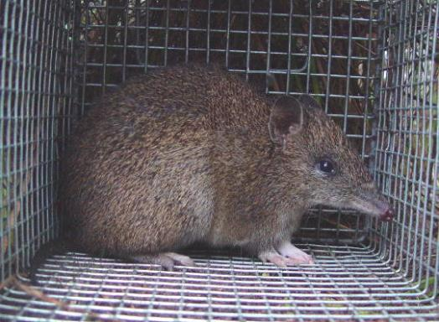
Figure 1: Southern Brown Bandicoot (Source: Mark Bachmann)

Behaviour
Southern Brown Bandicoots may be active during the day or night, at which time they are predominantly solitary, foraging alone (Menkhorst 1995). Typically, they spend the day sheltering within a nest concealed in dense vegetation, although Lobert (1990) and Sanderson and Kraehenbuehl (2006) recorded considerable diurnal activity by the subspecies.
Lobert (1990) found that individuals were not territorial, with a high degree of home range overlap within and between the sexes. Home ranges are typically 0.5 – 6 ha in size (Lobert 1990; Brown 2004).
Foraging individuals make distinctive conical-shaped diggings (Figure 2) with their strong forelimbs, while in search of subterranean food resources in the soil and leaf litter. Several species can make diggings that are superficially similar to those excavated by foraging bandicoots (Rees and Paull 2000). Evidence of foraging activity within a patch of native vegetation may be extremely localised (Paull 1995), indicating that at various times, only small areas in a vegetation remnant may be utilised.
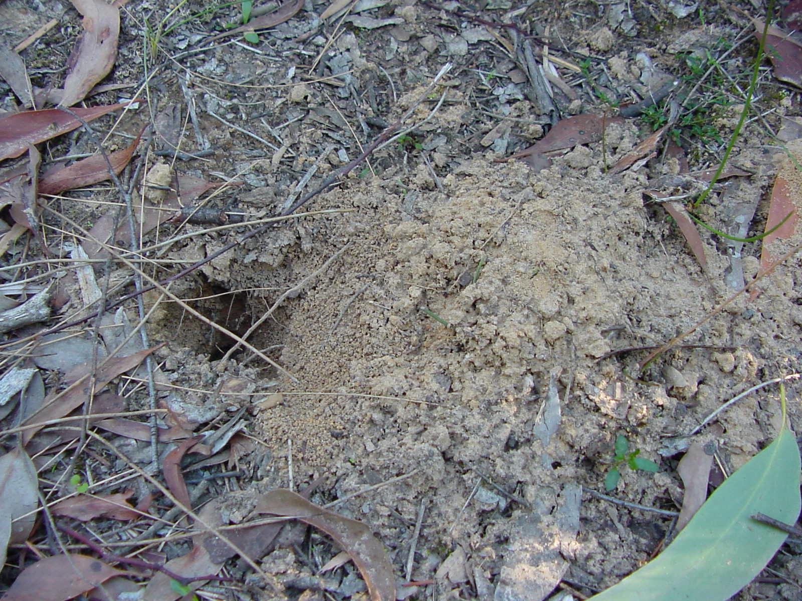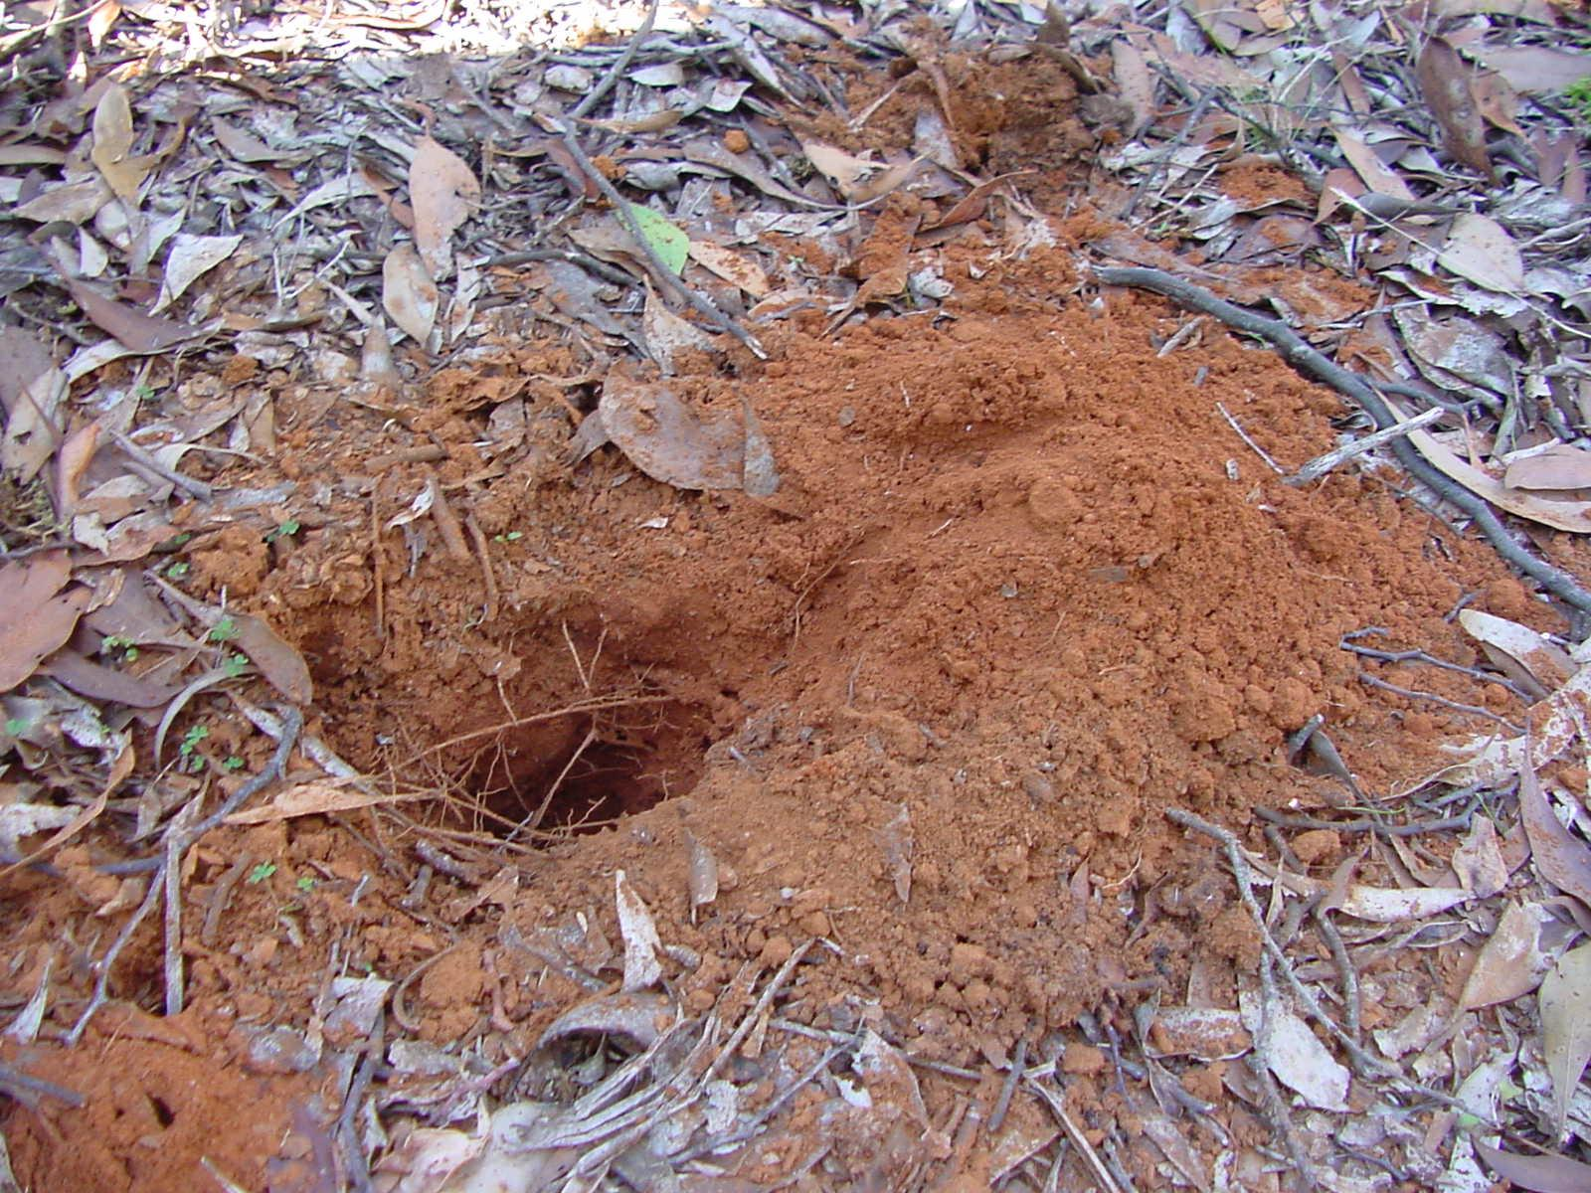
Figure 2: Digging in sand and terra rossa soils (Source: Mark Bachmann)

Diet
Southern Brown Bandicoots are omnivores, their main diet consisting of invertebrates, tubers, seeds and the sporocarps of hypogeal fungi (Claridge et al. 1991). Based on the analysis of 48 faecal samples collected in Tasmania, Quin (1988) concluded that the species was an opportunistic omnivore that feeds on a wide range of plant material and invertebrates. Items that have been recorded in the species’ diet include beetles (Scarabaeidae, Staphylinidae, Coleoptera), earwigs, Lepidoptera larvae, earthworms, ants and ant pupae, earthworms, Diptera larvae, Hemipterans, Calliphoridae larvae, grass and plant material, seeds and hypogeal fungi (Stoddart and Braithwaite 1979; Quin 1988; Claridge et al. 1991).
Lobert and Lee (1990) noted that prolonged periods of very dry or very wet conditions may detrimentally affect the soil microhabitat of invertebrate food sought by I. o. obesulus. Quin (1988) also noted that seasonal changes in the species’ diet appeared to reflect changes in the availability of various food items.

Reproduction
Southern Brown Bandicoots are capable of breeding throughout the year (Sanderson and Kraehenbuehl 2006), however seasonal peaks in reproductive activity may be evident in different parts of the species’ range (Menkhorst 1995). In a review of bandicoot breeding seasonality, Barnes and Gemmell (1984) identified the peak breeding period in south-eastern Australia to occur between September and November. A non-breeding period may occur between April and June (Barnes and Gemmell 1984). Stoddart and Braithwaite (1979) observed breeding by females to be highly synchronised, and suggested that this may be in response to changing photoperiod (day length). Barnes and Gemmell (1984) found that the percentage of lactating female bandicoots was correlated with the rate of change of minimum temperatures.
The gestation period of the Southern Brown Bandicoot is short (< 15 days) and litters may be produced in rapid succession (Lobert and Lee 1990; Menkhorst 1995). Females have eight teats and litter sizes range from 1 – 6 (typically 2 – 4) (Stoddart and Braithwaite 1979; Braithwaite 1995). Young are weaned at 60 – 70 days of age (Braithwaite 1995). Females are polyoestrous and may produce up to three litters per year during favourable conditions (Stoddart and Braithwaite 1979; Lobert and Lee 1990).

Nesting
Paull (1995) located approximately 30 bandicoot nests in the SE region. All were situated at the base of mature Xanthorrhea australis with large “skirts” of dead foliage extending to the ground. In models based on 40 nests located at Honan Native Forest Reserve (NFR), Paull (2004) found that X. australis with a stem height of 35–75 cm from the ground, to the base of the apical shoot, were used most frequently for nesting. When a site is burnt, these shelter sites are consumed by the fire, and hence become temporarily unavailable (Paull 1995). Lobert (1990) described the subspecies’ nests as being 50–75 cm in length, with a small internal chamber lined with twigs and leaves.

Critical threats
Despite the patchy persistence of the Southern Brown Bandicoot throughout much of its original range, the subspecies has experienced marked declines in most areas, particularly throughout New South Wales and SA, including the SE (Lunney and Leary 1988; Friend 1990; Menkhorst and Seebeck 1990; Paull 1995; Brown 2004).
Key identified threats and threatening processes affecting the survival of Southern Brown Bandicoot across its range include:
- habitat loss and isolation;
- inappropriate burning regimes; and,
- the potential impact of introduced predators.
These threats, originally identified in Harley (2006), are still considered to be relevant and the priority threats affecting Southern Brown Bandicoot recovery in the SE region.

Current status
The Southern Brown Bandicoot is listed as nationally Endangered under the EPBC Act 1999. At a state level, it is listed as Endangered under the South Australian National Parks and Wildlife Act 1972 and as Threatened under the Victorian Flora and Fauna Guarantee Act 1988.
Foulkes and Heard (2003) and Gillam and Urban (2011) consider the subspecies to be vulnerable in the SE region, as a result of various threats, noting that habitat clearance is one of the major reasons for the subspecies’ decline during the past century.
Surveys to date have focussed on detecting presence/absence and have not estimated population sizes. Bandicoots persist in the SE of SA in three core-populations: Caroline Forest, Mount Burr Range, and Nangwarry Forest. A fourth population area is also recorded in Lower Glenelg River CP (a small SA Reserve to the east of the Glenelg River), contiguous with Lower Glenelg National Park in Victoria.
Although most sites where the subspecies remains in the SE are small areas of native bushland, the species’ high fecundity gives it the capacity to colonise or recolonise sites where favourable conditions exist, if they are within close enough proximity. Indeed ForestrySA have observed bandicoots returning to sites post-fire, such as Windy Hill, Hackett Hill, Burr Slopes South, Wandilo, and Kay NFRs, as well as the Mt McIntyre area (T. Horn, pers. comm, 2006). ForestrySA’s Biodiversity Corridors Strategy was developed specifically to increase connectivity between remnant native vegetation, with the Southern Brown Bandicoot as a focal species. The 25-year strategy has been in place since 2003 and aims to establish 24 biodiversity corridors (Horn 2003).
The subspecies has been subject to a draft National Recovery Plan (NRP) (Brown & Main 2010), and recovery plans in New South Wales (DEC 2005) and the Mount Lofty Ranges in SA (Haby and Long 2005).

Conservation effort towards Southern Brown Bandicoot recovery in the South East (pre 2006)
The Southern Brown Bandicoot has been the subject of substantial research and on-ground works in the SE region, prior to 2006. A summary of this is provided here (updated from Harley 2006).
Paull (2004) conducted digging abundance surveys in 29 patches of remnant vegetation in the SE during 1998 and 1999. Digging abundance surveys were conducted within 100 x 100 m quadrats, with each quadrat awarded a digging frequency class. A similar method was employed by DEWNR in 2007/08 (Le Duff et al., 2009) and repeated by NGT in 2016 (Bachmann and Fullagar, 2017). Please refer to Appendix 2 for detailed methodology.
Digging sites were located in a broad range of landscape situations; however, they were most commonly associated with slopes and ridges consisting of well-drained, grey-coloured soils. Results from the 1998/99 surveys indicated that diggings were most frequently noted at sites supporting 60-80% groundcover below one metre, particularly at sites with high floristic diversity or where Xanthorrhoea australis, Pteridium esculentum, Leptospermum spp. or Melaleuca spp. were present. Presence of diggings were not strongly affected by the depth of leaf litter on the ground.

The following is an itemised summary of conservation efforts (pre 2006):
- A series of field studies were undertaken from the mid-1990s to mid-2000s investigating the distribution of Southern Brown Bandicoot populations in the SE, including a review of historical records (Paull 1995, 1999, 2004).
- The Biological Survey of the SE detected bandicoots on 10 occasions in 1997 (Foulkes and Heard 2003).
- ForestrySA commenced planting biodiversity corridors between NFRs from 1998-2000 initiated by Barrie Grigg. The establishment of biodiversity corridors was aimed at assisting any fauna but in particular the Southern Brown Bandicoot.
- Trapping surveys undertaken at a number of sites throughout the region, including genetic sampling (by ear biopsy), facilitated future investigation into population fragmentation of the Southern Brown Bandicoot (2001-2007). This included establishing trapping grids at Lower Glenelg River Conservation Park which were surveyed annually during those years.
- ForestrySA (Troy Horn) developed the SE Biodiversity Corridors Strategy in 2003. Implementation of the strategy commenced in 2003 and by 2006 eight corridors had started (Sharn Lucas – Biodiversity Corridors Project Officer).
- ForestrySA conducted trapping surveys in several NFRs situated in the Lower SE from 2003 onwards, with multiple Southern Brown Bandicoot captures.
- The Glenelg Ark project commenced in 2005 to undertake broad scale fox control to reduce impacts on small mammals (i.e. Southern Brown Bandicoot, Long-nosed Potoroo, and Common Brushtail) in south-western Victoria; adjacent to and influencing Lower Glenelg River CP.
- Seasonal fox baiting was conducted annually by ForestrySA at several NFRs in the Lower SE.
- Sites where prescribed burning and bushfires occurred were accurately mapped by fire organisations (including ForestrySA, DEWNR and DELWP - long-term fire history datasets exist for all reserves). These have been used for bandicoot recovery activities.

EXISTING ACTION PLANS
An overview of the objectives included in the NRP and SE RAP for Southern Brown Bandicoot is provided in this Section. The associated objectives, performance criteria and actions have been used to form the basis of the review in Section 4.

3.1 National and state plans
Draft National Recovery Plan
Brown and Main (2010) consider the Southern Brown Bandicoot populations in SA to be under threat. Most populations are relatively small and isolated. Key management authorities in SA are DEWNR, SA Water and ForestrySA. Some populations occur on private land and on land managed by local government.
Identification of potential habitat to better define the distribution and size of populations is considered an important action. Major threats include introduced predators, extensive bushfires and inappropriate burning regimes, habitat degradation and destruction.
Recovery actions are primarily aimed to:
- acquire baseline data
- assess habitat condition including biological function
- protect populations to maintain or improve population growth
- involve the community in recovery actions.
Action Plan for Australian Mammals
The 2012 Action Plan for Australian Mammals (Woinarski et al. 2014) provides an extensive scope and has the capacity to provide guidance for action at the local level, relevant to this RAP document. There has been no published, robust estimates of Southern Brown Bandicoot total abundance, nor its overall rate of decline. Densities are broadly documented as between 20-200 individuals per sq km. Threats such as fox predation and fragmentation are considered a severe threat as they operate over a large proportion of its range, whereas inappropriate burning regimes are considered only a minor threat of moderate consequence.
Information gaps identified by Woinarski et al. (2014) include:
- the need for survey to better define distribution (medium to high priority)
- the need to identify landscape scale options for habitat retention and connectivity (medium priority).
Commonwealth Conservation Advice
In the absence of a finalised and approved National Recovery Plan, this brief advice statement provides an equivalent function and includes a set of high-level management actions designed to address threats such as habitat loss/modification, invasive species, fire, etc. It also includes actions focussed on developing a comprehensive population monitoring program and community engagement, as well as addressing fragmentation through improving connectivity and options for translocations for non-viable sub-populations (TSSC 2016).
The committee recommended that I. obesulus ssp. obesulus retain the listing status of Endangered under the EPBC Act. This advice was approved by the Minister on 5 May 2016 after a public consultation period (December 2014 to February 2015).
Actions (with priority) from TSSC (2016)and relevant to the SE RAP include:
- establish corridors between fragmented populations (high)
- implement predator control programs (high)
- implement fire regimes that minimise impacts to the species (high)
- implement a comprehensive monitoring program; to determine numbers in sub-populations, trends in abundance and distribution (high)
- protect and maintain habitat in all areas where this species currently occurs (high)
- assess options and risks associated with translocations for non-viable sub-populations (medium)
- implement an integrated monitoring program across this species range (medium)
- involve the community in conservation management of this species (low-medium)
- establish or maintain a captive breeding program for re-introductions (low-medium)
- manage weeds in a manner that delivers overall benefit for this species (low-medium).

3.2 South East Regional Action Plan
Aim and objectives
The primary aim of the original RAP (Harley 2006) was to identify the strategies necessary to conserve the three core populations of Southern Brown Bandicoot present in the SE of SA. The implementation of appropriate fire regimes, habitat management and predator control were considered the key steps to achieving this (Harley 2006).
The recovery target for that plan was to (over the coming three decades):
- ensure the persistence of bandicoot populations at a minimum of 2 remnant patches of native vegetation in the Caroline Forest (i.e. Dry Creek and Honeysuckle NFRs) and in 15 remnants on the Mt Burr Range. At least eight of these populations should comprise 20 or more individuals.
Management actions considered necessary for the conservation and recovery of Southern Brown Bandicoot populations in the SE region were then outlined in order of priority. These actions are outlined and reviewed in Section 4.

REVIEW OF THE SOUTH EAST REGIONAL ACTION PLAN
This summary is a collation of achievements by community groups, three local schools, ForestrySA, DEWNR, and NGT ecologists during the period 2006 to 2016. Actions (in grey boxes) are from the original SE Southern Brown Bandicoot RAP; and are listed under objectives addressing key threats; and align with those included in the draft National Recovery Plan (Brown and Main 2010).

4.1 Achievements against the South East Regional Action Plan
Objective 1: Ensure that existing bandicoot populations and their habitat are protected and managed
Action 1. – Undertake site-based habitat management works at localities supporting extant populations of bandicoots.
Action 1.1 - Protect and enhance the habitat and food resources available to bandicoots through the implementation of appropriate burning regimes.
Action 2. - Implement long-interval fuel reduction burns (>15 years) at strategic localities to minimise the risk of wildfire destroying large areas of bandicoot habitat.
The bulk of site-based habitat management works at localities supporting bandicoots in the South East is through prescribed burning and woody weed control. The importance of fire regime in the management of Southern Brown Bandicoot habitat is relatively well understood as previously documented in Harley (2006) and highlighted further in Bachmann & Fullagar (2017). Time since fire is an important variable in monitoring populations as it influences habitat suitability (structure and composition) and food resource availability; however, bandicoot occupancy and activity typically recover within 5-7 years after fire (Bachmann and Fullagar, 2017). A good example is Wandilo NFR where a bushfire burnt almost the entire reserve in 2000, but saw bandicoots return within six years.
ForestrySA and NRSE produce prescribed burn plans for reserves under their management, including almost all known bandicoot sites in the South East NRM region. ForestrySA has delegated authority from the Native Vegetation Council (NVC) to undertake prescribed burns in NFRs, provided relevant environmental considerations are taken into account (ForestrySA 2011). ForestrySA and the NVC have a set of agreed management processes in place and ForestrySA conduct prescribed burns under the procedures set out in the Manual for Prescribed Burning (ForestrySA 2013).
ForestrySA have developed 25-30 year fire cycles for their larger NFRs which aim for burning to be undertaken in such a way that the equivalent total area of the reserve will be burnt over a 30 year period. Scientific reference areas which contain populations of fire sensitive flora and/or fauna species are generally excluded from this burning program, subject to management considerations or the emergence of new threatened flora or fauna records. The main purpose of a scientific reference area is to remain long unburnt, act as a refuge, and to facilitate re-colonisation to adjacent regenerating compartments. Scientific reference areas occur in 18 NFRs that support Southern Brown Bandicoots.
Relevant Southern Brown Bandicoot management strategies listed in the SE Fire Management Plan 2010-2020 are as follows (DEH 2010: 26):
- Conduct prescribed burning to increase habitat patchiness and minimise the risk of large areas (50%) of meta-population habitat burning in one fire event. (Achieved)
- Attempt to provide unburnt patches within, and adjacent to, burn areas as refuge during prescribed burning or bushfire suppression activities. (Achieved)
- Prepare an Ecological Fire Management Strategy for the Southern Brown Bandicoot to guide the planning and the implementation of prescribed burns in known Southern Brown Bandicoot habitat. (refer to Bachmann & Fullagar, 2017)
- Consult with the relevant recovery team and ForestrySA during the planning of any prescribed burn to be conducted within known habitat of the species. (Not achieved)
- Assist with fire management strategies to meet the conservation requirements of the Southern Brown Bandicoot. (refer to Bachmann & Fullagar, 2017)
Prescribed burning during the period of the previous plan has been undertaken by ForestrySA. Operational and Environmental Burn plans have been consistent with meeting the requirements of the Southern Brown Bandicoot. One bushfire occurred as a result of an escaped planned burn (in Dry Creek) scorching 3 additional compartments, and a single unplanned bushfire burnt (parts of Glencoe Hill, and The Woolwash NFR’s and the entire Long and Mount Watch NFR’s) in 2015.
The initial response at these locations is encouraging, with evidence of diggings found at two of the five burnt sites (Glencoe Hill & Windy Hill). On the basis of previous digging abundance survey data, Southern Brown Bandicoots would be expected to return to all of these burnt sites 5-7yrs post-fire, noting however that the fire in Dry Creek NFR occurred in a population area where bandicoots are under apparent duress (which may impact on their post-fire recovery) (Bachmann & Fullagar, 2017). These sites should be monitored across this time period using criteria and the methodology developed as a result of this review. Fire creates an opportunity to also address weed issues if they emerge during vegetation regeneration at these sites.
Action 1.3 - Control invasive plants, particularly woody weeds such as Coastal Wattle (A. longifolia var. sophorae) and Sallow Wattle (A. longifolia var. longifolia).

Certain invasive species such as Acacia longifolia (both Coastal and Sallow varieties, and their hybrids) cause “shrubbing up” of native bushland, which can impact on ground-dwelling species such as the Southern Brown Bandicoot by simplifying understorey vegetation composition and structure, and diminishing the number of flora species present. Due to the widespread regional distribution of Acacia longifolia, all remaining Southern Brown Bandicoot sites require monitoring and control (also including other woody weeds) as necessary. Weed control methods usually involve physical control by hand or chainsaw/handsaw.
The management of environmental weeds within and adjacent to NFRs is a priority for ForestrySA. Integrated five year management plans are in place which target specific weed species, including Acacia longifolia ssp. sophorae and Acacia longifolia ssp. longifolia and their hybrids, in high conservation areas.
ForestrySA staff, contractors, and volunteers utilise the latest research to target specific woody weeds with the most appropriate control techniques (fire, mechanical, biological, chemical) to minimise the environmental footprint (ForestrySA 2011).
A database of NFR compartments is maintained by ForestrySA and used for developing and implementing the orgnaisation’s annual weed management program. An example of compartments treated during the 2006-16 period can be found in Table 1.
Table 1: Example of NFR compartment weed treatments for the period 2006-16 (source: ForestrySA)
Volunteers through the Friends of Parks also remove woody weeds in NPWSA reserves within the range of the Southern Brown Bandicoot. Over 650hrs have been spent removing wild pines and other woody weeds, and planting corridor sites at Gower, Penambol, Telford Scrub and Lower Glenelg River CP’s during the 2006-2016 period (Source: Kevin Mott, Mt G Friends of Parks, 2017).

Objective 2: Identify threats and threat abatement management practices to assist the recovery of the Southern Brown Bandicoot
One broad action not identified in the previous RAP however deserving recognition in this review includes the establishment of biodiversity corridors to address fragmentation of Southern Brown Bandicoot populations. Eight corridors had commenced their establishment pre-2006, and a further 3 corridors were commenced during the 2006-2016 period. Eleven corridors in total are well underway, with 24 scheduled to be established and/or commenced by 2025 (Horn 2003).
A long-term school biodiversity corridor education program was set up by Peter Spinks (ForestrySA) in 2007 at three schools in the lower south east.
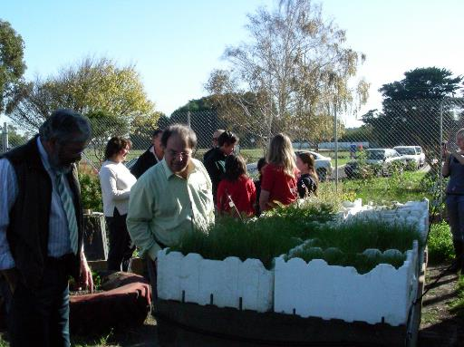
Figure 3: Peter Spinks Community Programs Coordinator (left) and Jim O’Hehir, ForestrySA (right) at Newbery Park PS nursery, 2009.

This program continues today and includes the Millicent High School, Newbery Park Primary School, and Glenburnie Primary School. School Support Officers are employed part-time to help each school facilitate learning and assist in coordinating the collection of native plant seed, seedling propagation in each schools nursery and eventual planting in the field. Kathy Bell (Millicent HS) and Angela Jones (Newbery Park and Glenburnie PS’s) have been instrumental in integrating these programs into each school. It has involved ensuring the biodiversity activities are relevant to their respective curriculums, increasing the teacher and student knowledge of local biodiversity (especially target species for each corridor especially Southern Brown Bandicoots); and teaching the students practical nursery and field based skills, through a variety of enjoyable activities assisted by ForestrySA ecologists, during each calendar year.
Students of all ages have been involved, not just in the collecting and propagating of the plants, but also in learning about each target animal species and its ecological requirements. Removing weeds and managing sites has also been a component of this program (Figure 4).
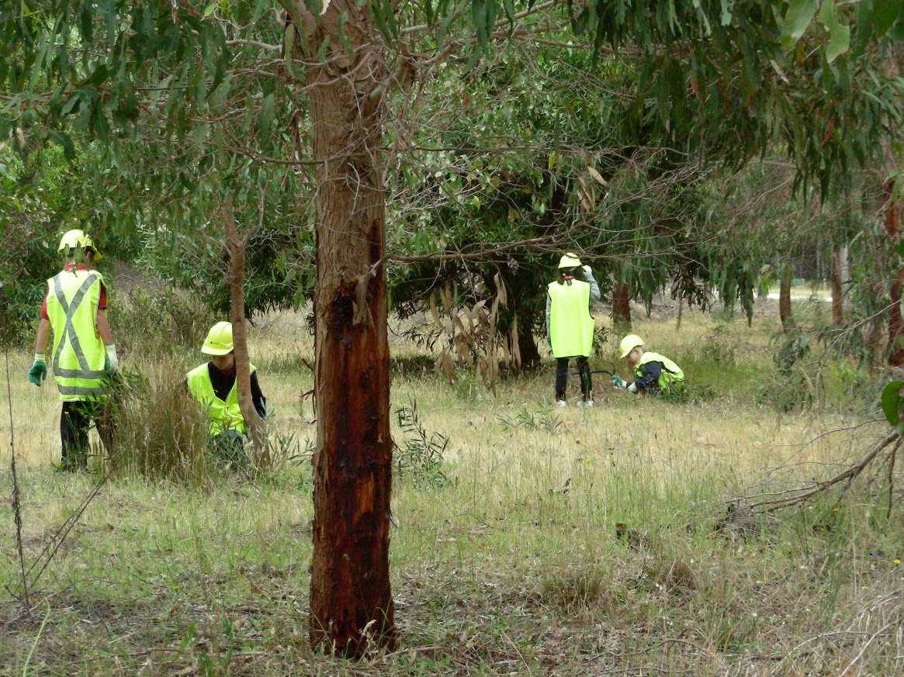
Figure 4: Newbery Park Primary School students removing woody weeds in the Bluff to Windy Hill Corridor (2008). Source: ForestrySA
Over 10,000 plants per year have been grown by the three schools to be planted out in corridor sites within the Mt Burr and Caroline core population areas (since 2007). Community Services Obligation funding (from the Department of Primary Industries and Resources) is received by ForestrySA each year to support this excellent program which continues today.

Photopoint examples of Biodiversity corridor sites:
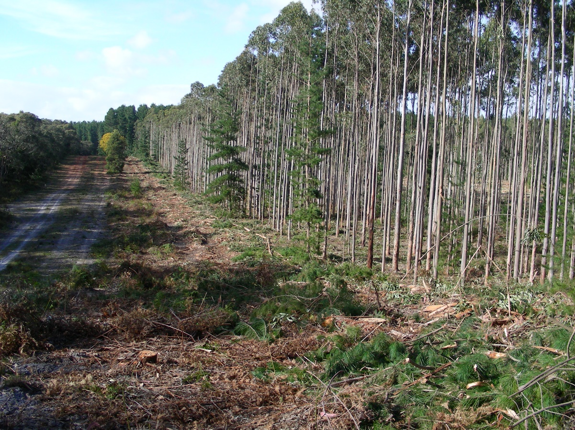
Dry Creek to Honeysuckle corridor (ex Blue Gum plantation) - December 2012 (Source: ForestrySA)
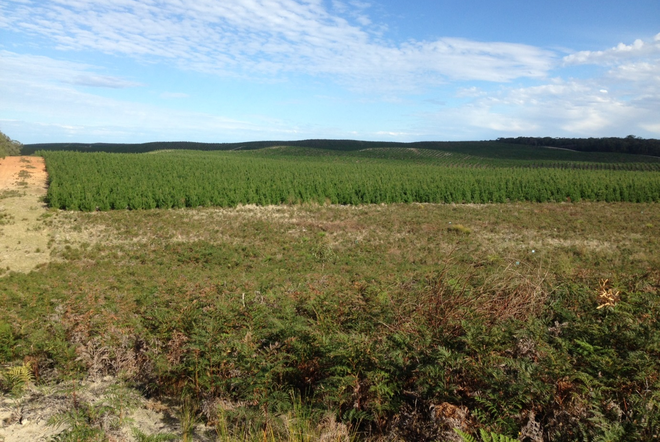
Dry Creek to Honeysuckle corridor (showing recovery of bracken) - May 2017
Figure 5: Dry Creek to Honeysuckle biodiversity corridor

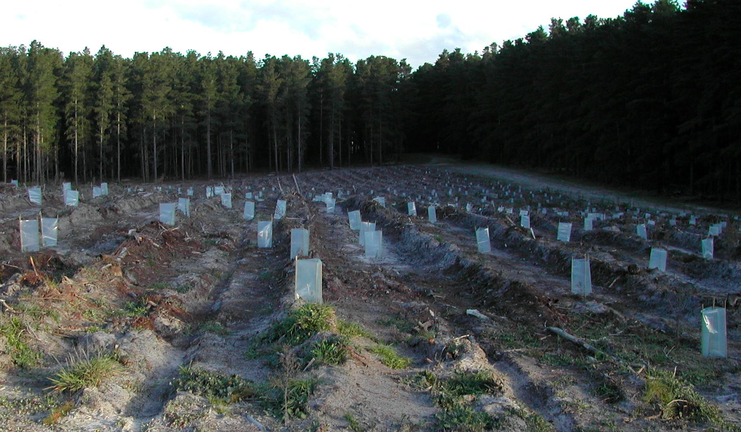
Gower to Windy Hill corridor – 2004 (Source: ForestrySA)
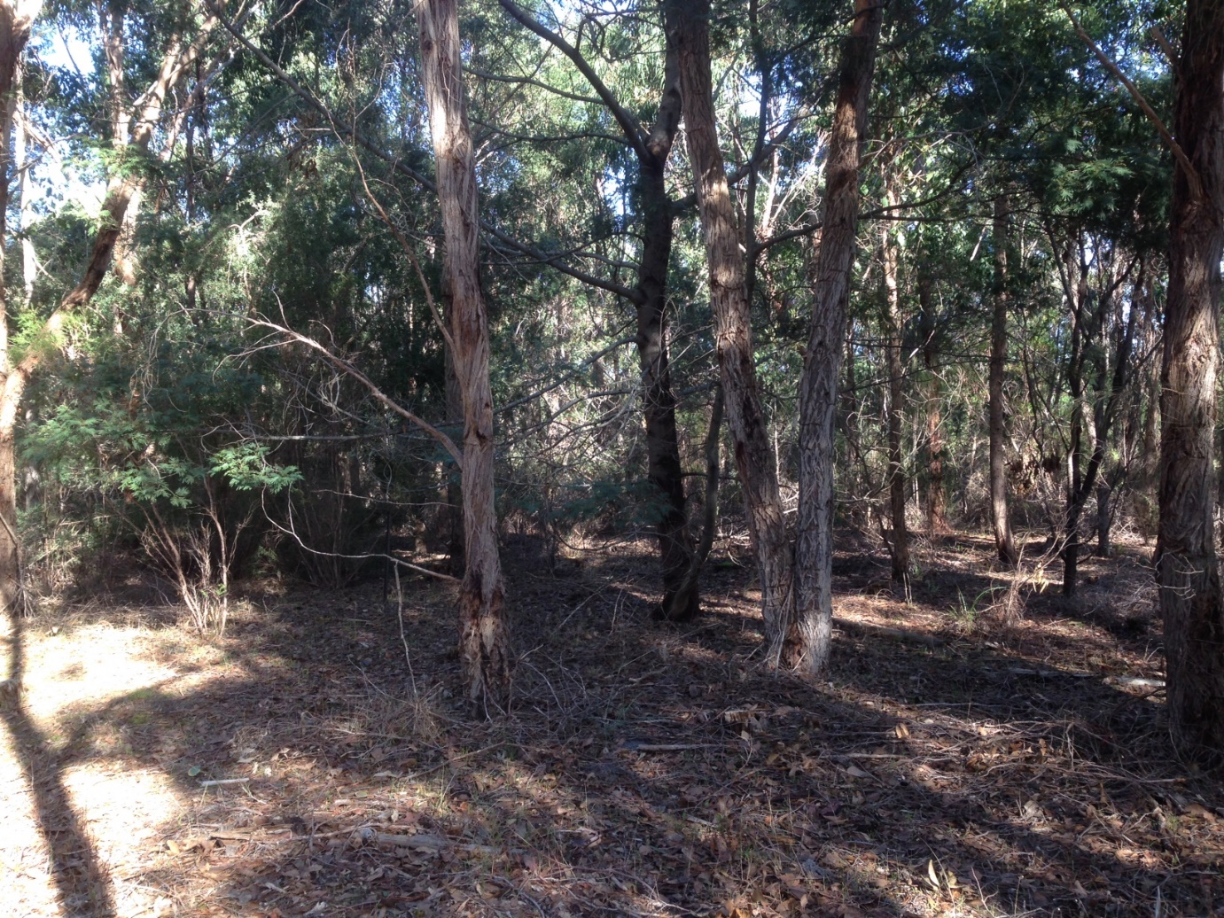
Gower to Windy Hill corridor – May 2017
Figure 6: Gower to Windy Hill biodiversity corridor

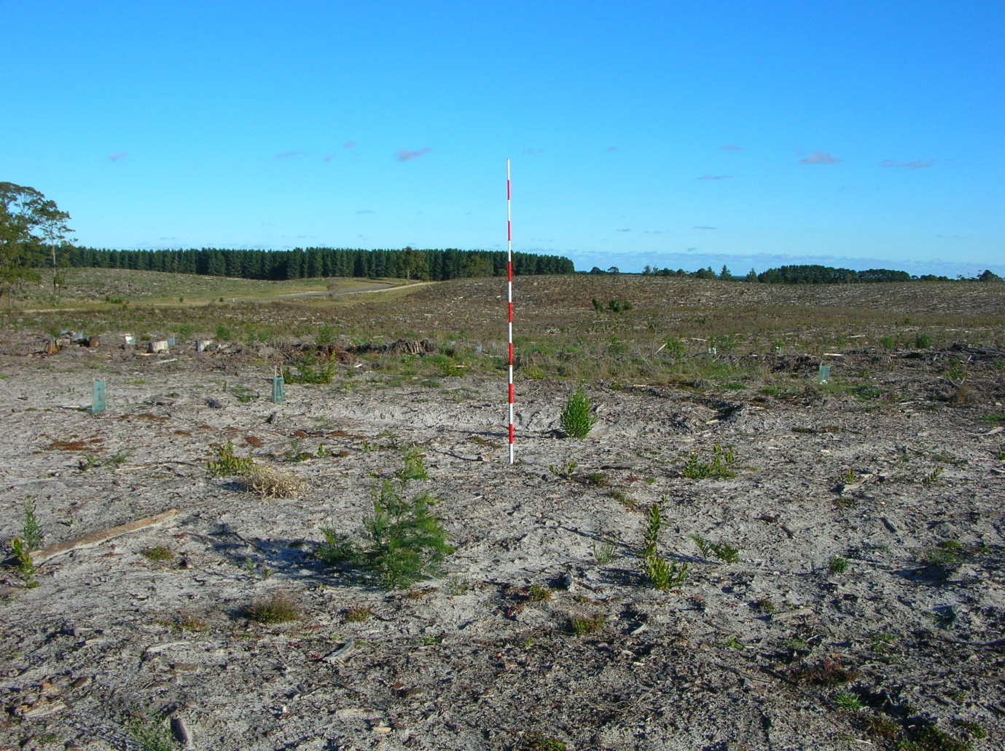
Honan to Woolwash corridor - 2004
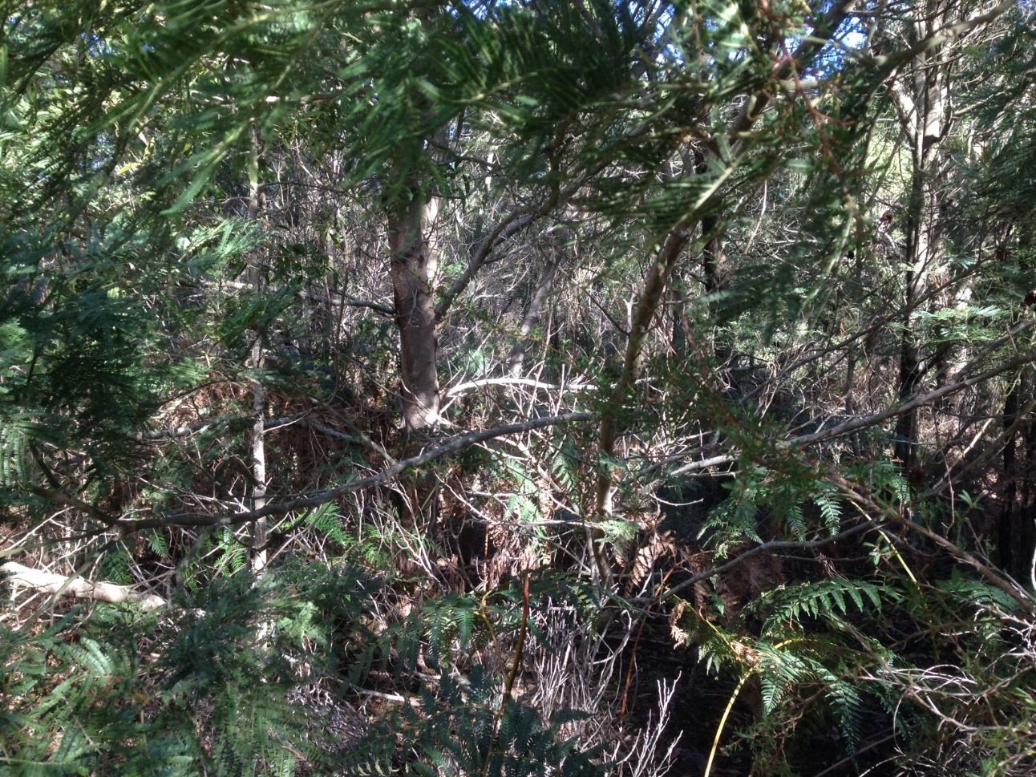
Honan to Woolwash corridor - 2017
Figure 7: Honan to Woolwash biodiversity corridor

Action 12. - Identify opportunities to reduce the number of tracks bisecting the Native Forest Reserves managed by ForestrySA.

Internal tracks through remnant vegetation have the potential to decrease foraging safety and increase predation of small ground dwelling animals. This was highlighted as a potential improvement in native forest management in Harley (2006).
During the period of the previous RAP numerous NFRs were targeted for track rationalisation to reduce the number of slashed tracks - facilitating predator movements, and to enlarge core areas of native forest compartments (Figure 8). Track rationalisation occurred in the following NFRs:
- Kangaroo Flat | - McRosties
- Hackett Hill | - Marshes
- Honan | - Wandilo
- Mt McIntyre | - Whennen
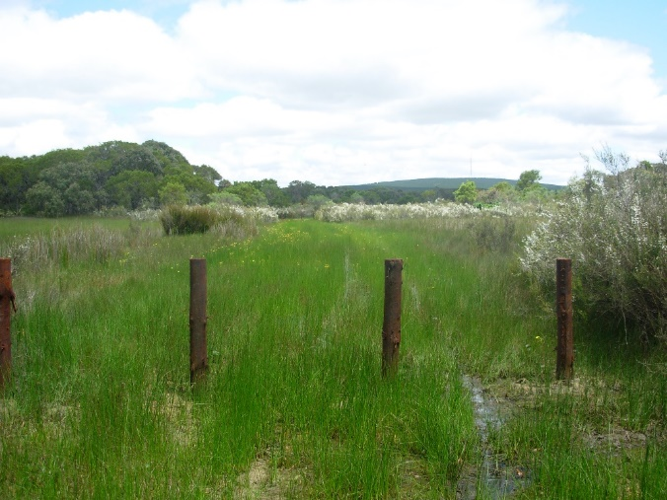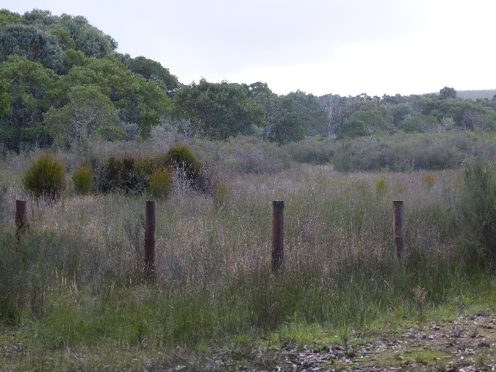
Figure 8: Example of track rationalisation in Marshes NFR (2010 compared to 2017)
It is unknown if private land sites have similar issues with wide slashed tracks through Southern Brown Bandicoot habitat. This action should form part of the revised plan.

Action 3. - A detailed plan for controlling introduced predators at sites supporting extant bandicoot populations should be developed.

In the South East NRM region, the European Red Fox and Feral Cat have been implicated in the decline of many small to medium sized ground-dwelling mammals. In one local study, five percent of fox scats (95 scats) were found to contain Southern Brown Bandicoot remains (Paull, 1999).
ForestrySA’s operational management is driven by its Forest Management System (FMS). Operations are planned, managed, monitored and reviewed in accordance with a range of policies, procedures and Standard Operating Procedures (SOP’s) which all form part of the FMS. ForestrySA develops Operations Plans for a range of operational activities including plantation establishment, harvesting, roading, pest and disease control, biodiversity and conservation management, maintenance of visitor facilities and heritage and community programs (ForestrySA 2014).
A specific plan for controlling introduced predators at bandicoot sites was not developed, however ForestrySA and DEWNR have policies in place relating to predator control, which were implemented during the previous RAP period in reserves where bandicoots occur. Development of a plan was considered unnecessary. However, advice for landholders with Southern Brown Bandicoots could be provided in the future.
A detailed explanation of some of the confounding factors relating to predator control in the specific context of the Southern Brown Bandicoot is presented in the discussion section of the Surveys of Digging Abundance of the Southern Brown Bandicoot in the South East of South Australia report (Bachmann and Fullagar, 2017).

Objective 3: Determine the distribution, abundance and population structure of the Southern Brown Bandicoot
and
Objective 5: Evaluate population responses of the Southern Brown Bandicoot to recovery actions, and adapt actions as required
Action 4. - Clarify the species’ ongoing presence at sites where it has been detected since 1990.

The Southern Brown Bandicoot populations of the SE have been monitored regularly to ensure on-going occupancy across habitat patches within its range. Additionally, this data helps to inform management actions so they can be prioritised and applied efficiently. The digging abundance survey method of monitoring is a rapid and non-invasive way of assessing bandicoot presence and activity (see Appendix 2). Searches for distinctive Southern Brown Bandicoot diggings take place within one hectare survey areas, and the observed diggings (including abundance of each) are allocated to one of three age classes (fresh, recent, old). Digging abundance surveys were undertaken in 1998/99, 2007/08 and 2016 (Le Duff et. al, 2009; Bachmann and Fullagar, 2017).
Records of bandicoot presence have also resulted from identification of hair tube samples, physical captures in Elliot or cage traps and/or from observations provided by field workers, property owners and/or local nature enthusiasts, who are familiar with the Southern Brown Bandicoot.
The list of sites where the Southern Brown Bandicoot has been known to occur since 1990 is presented in Table 2.

Patch | Core population
Dry Creek | Caroline
Honeysuckle | Caroline
*Warreanga | Carolineᵃ
*Penambol CP | Carolineᵃ
*Lower Glenelg River CP | Lower Glenelg#
*Private - Graetz | Lucindaleᵇ
*Private – Aslin’s | Mt Burr
Private - Brooksbys | Mt Burr
Burr Slopes South | Mt Burr
Glencoe Hill | Mt Burr
Gower CP | Mt Burr
*Gran Gran Inlier (adjacent Cpt 104) | Mt Burrᶜ
Grundy Lane | Mt Burr
Hackett Hill | Mt Burr
Honan | Mt Burr
Kangaroo Flat | Mt Burr
Kay | Mt Burr
Lake Leake | Mt Burr
Long | Mt Burr
McRosties | Mt Burr
Mt Lyon | Mt Burr
Mt McIntyre | Mt Burr
Mt Watch | Mt Burr
Native Wells | Mt Burr
Overland Track | Mt Burr
*Private - Maxwell | Mt Burrᵈ
The Bluff | Mt Burr
The Marshes | Mt Burr
The Woolwash | Mt Burr
Wandilo | Mt Burr
Whennen | Mt Burr
Windy Hill North | Mt Burr
Windy Hill South | Mt Burr
Private - Byrnes (McBain) | Nangwarry
Private - Paltridges | Nangwarry
Private - Yeates | Nangwarry
The Heath | Nangwarry
Table 2: Sites where Southern Brown Bandicoots have been known to occur since 1990
Note: ᵃ = pers, comm, T Horn, 2017; ᵇ = Hair tube record from 1997; ᶜ= diggings observed by author in 2013; ᵈ = pers. comm, S Maxwell, 2015; * = current occupancy of these sites is unknown as they do not form part of the digging abundance surveys; # = subject to semi-regularly trapping surveys, but not recorded since 2007.

Action 15. - Determine whether the species still occurs at the outlying site west of Lucindale where it was hair-tubed in 1997 during the Biological Survey of the South East.
During the Biological Survey of the SE in 1997 (Foulkes and Heard 2003), an outlying record of the Southern Brown Bandicoot was obtained on private property to the west of Lucindale (M. Bachmann, pers. comm.). The site contains Brown Stringybark (Eucalyptus baxteri) and Manna Gum (Eucalyptus viminalis cygnetensis) woodland with a dense understorey. The record was obtained via hair-tubing, and a subsequent trapping survey failed to recapture bandicoots (M. Bachmann, unpubl. data). The species’ potential occurrence in this area warrants further clarification.
Many large patches occur in this part of the SE region with some areas of habitat that appear superficially suitable for bandicoots and display relatively good connectivity, despite being well outside the current range of the species in the region. Follow up is considered a high priority during the implementation of the revised RAP, to clarify if (despite being unlikely) another regional population may exist. Figure 9 includes a map of vegetation patches which could be targeted for future bandicoot surveys in attempt to identify the persistence of another population.
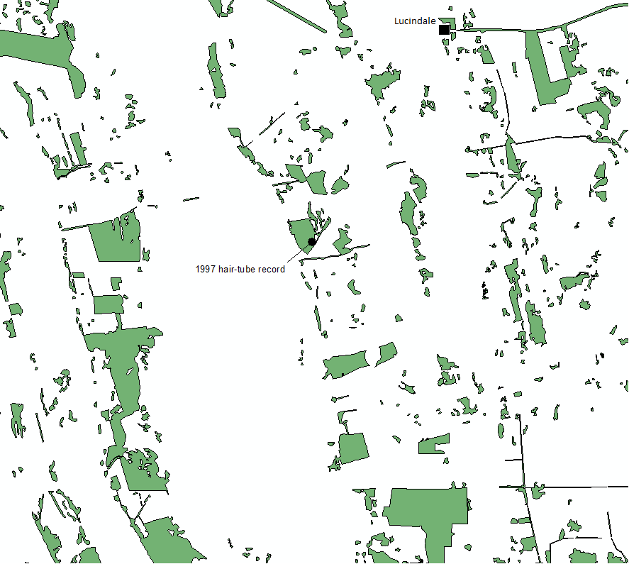
Figure 9: Patches of Eucalyptus woodland south-west of Lucindale and the site of the hair tube record.
Action 5. - Develop a standard protocol for assessing bandicoot abundance in vegetation remnants, potentially using a combination of conventional trapping, digging transects, hair tubes and camera traps. This technique must have sufficient power to reliably detect temporal changes in the species’ abundance at a site.
Action 6. - Establish the abundance of bandicoots at all sites where the species has been recorded previously to determine the condition of all extant populations in the region.
The Southern Brown Bandicoot populations of the SE should continue to be monitored regularly to provide data on temporal changes in occupancy and activity (diggings), as well as ensuring management actions can be prioritised and applied efficiently. Digging abundance data can illustrate levels of Southern Brown Bandicoots activity in an area, and population movements and response to fire can be interpreted when compared to previous years’ data.
The preferred method of survey (determine presence) for Southern Brown Bandicoot is to use a combination of digging searches and hair tube/remote cameras (DoE, 2017). It is also recommended for this survey to be undertaken during late summer-autumn when the peak of recruitment (of young) into the population occurs.
Recommendations from Bachmann and Fullagar (2017) are for:
- For digging abundance surveys to be repeated at Mt Burr Range sites in 5 years, and at Nangwarry and Caroline sites on an annual or biennial basis to help guide any future management strategies within the updated Regional Action Plan.
- For implementation of more active interventions (translocations / reintroductions) to ensure populations are not lost from the Nangwarry and Caroline sites.
- To protect and maintain the region’s most viable Southern Brown Bandicoot population within the Mt Burr Range cluster of patches, through supporting the regional corridor strategy and giving serious consideration to a program of assisted migration (through translocations).
- To undertake supplementary searches if the regular digging abundance method fails to detect the presence of bandicoots in a patch.
It is considered necessary to develop a supplementary method to confirm presence/absence in a more rapid manner, noting that digging abundance surveys are effective, but limited in coverage and are time consuming. A supplementary method would include surveying patches which have not been adequately searched – Aslins, Maxwell, The Bluff, Gower CP and private land sites near Lucindale). The digging abundance survey protocol (including supplementary searches from Bachmann & Fullagar, 2017) is included in Appendix 2.
Action 6.1 - The size and distribution of bandicoot populations in the Caroline Forest.
The Southern Brown Bandicoot population in the Caroline Forest appears to be under duress (Bachmann & Fullagar, 2017). Recent field work observed their presence in both NFRs but at a reduced level of occupancy and distribution (Table 3).
Table 3: Caroline Forest NFRs and monitoring results for Southern Brown Bandicoots 1998-2016 (Source: Bachmann & Fullagar, 2017).
Patch name | Core population | Size (ha) | % sites occupied 1998/99 | % sites occupied 2007/08 | % sites occupied 2016 | % Difference occupied 2016 - 07
Dry Creek | Caroline | 419 | 27 | 64 | 24 | -40
Honeysuckle | Caroline | 258 | 14 | 29 | 15 | -14
A bushfire in Dry Creek NFR which escaped from a prescribed burn in November 2013, has potentially impacted in the short-term on the population in Caroline Forest. It is anticipated that the vegetation within this burnt area (which was largely suitable habitat for the Southern Brown Bandicoot) will become occupied in the near future and assist with the re-expansion of the bandicoot colony by 2020.
The small population in Nangwarry Forest is also under duress (Table 4).
Table 4: Nangwarry Forest NFRs and monitoring results for Southern Brown Bandicoots 1998-2016 (Source: Bachmann & Fullagar, 2017).
Patch name | Core population | Size (ha) | % sites occupied 1998/99 | % sites occupied 2007/08 | % sites occupied 2016 | % Difference occupied 2016 - 07
Byrnes/Yeates | Nangwarry | 373 | 67 | 33 | 11 | -22
Paltridges | Nangwarry | 67 | 0 | 50 | 33 | -17
The Heath | Nangwarry | 211 | 60 | 60 | 20 | -40

Private landholders should be encouraged to continue to consider the Southern Brown Bandicoot when management of their patches, particularly in relation to threat abatement (weeds, predators and track rationalisation).

Action 6.2 - Bandicoot abundance in Native Forest Reserve compartments reserved from prescribed burns.

As indicated earlier in this review, abundance data is not available, however we can report on the degree of occupancy in each reserved compartment. Management plans written for each NFR indicate whether a compartment is reserved from burning or not (see example in Figure 10). Of the 23 NFR’s supporting Southern Brown Bandicoots, 18 have Scientific Reference Areas (compartments (cpts) reserved from burning).

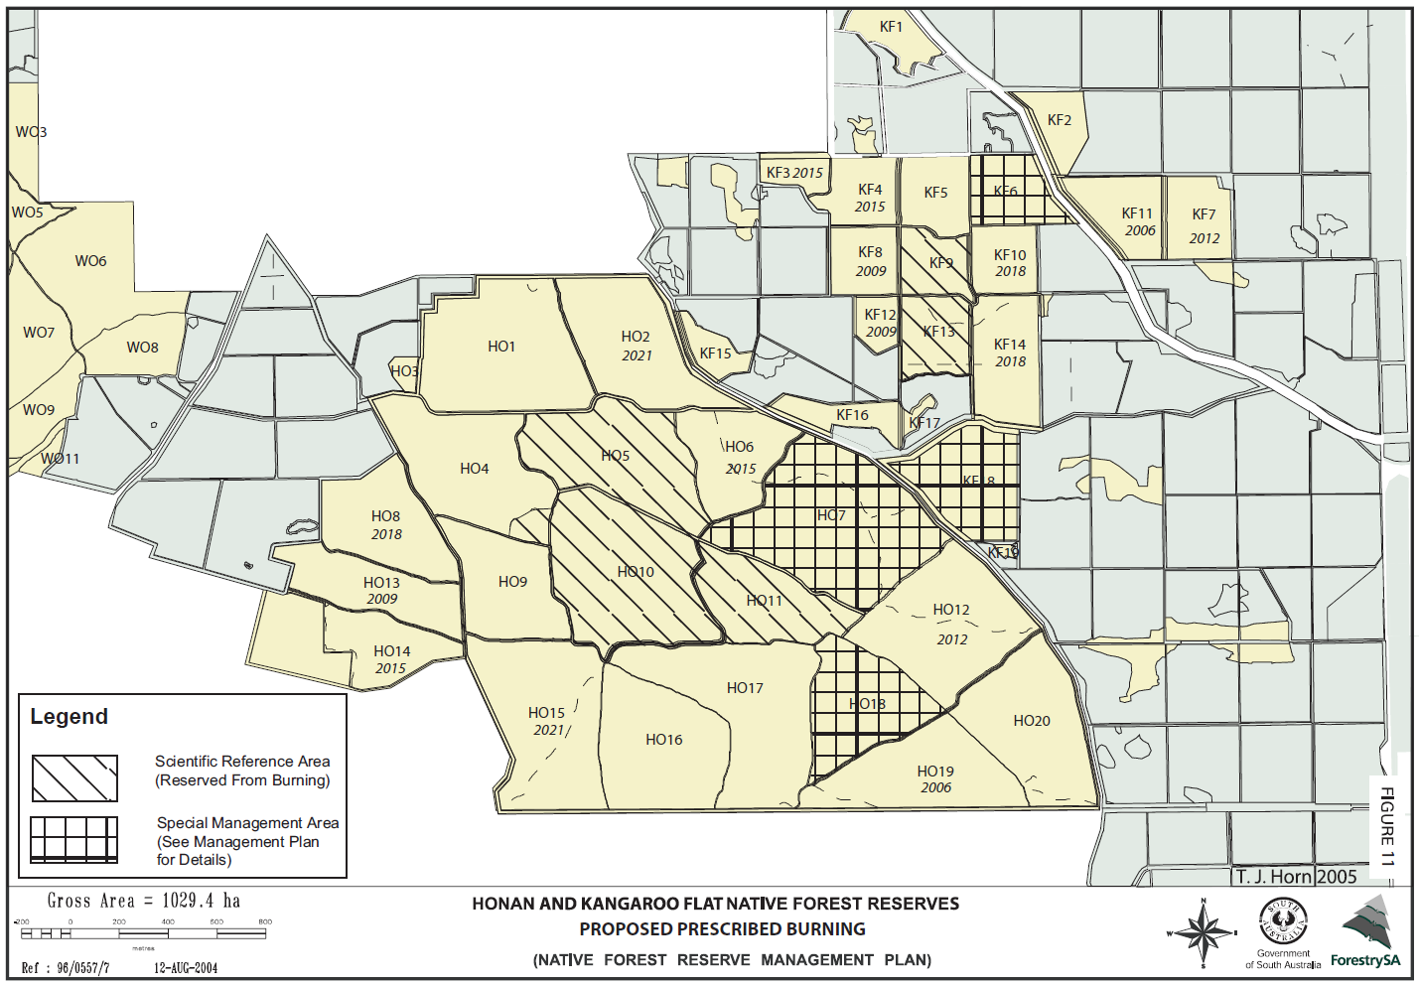
Figure 10: Example of a NFR management plan map showing compartments reserved from burning. Source: Honan NFR Draft Management Plan

The occupancy of these areas (Scientific Reference Areas) is summarised in Table 5.
Table 5: Fire history of Scientific Reference Areas in NFRs (and other patches) including presence/absence of Southern Brown Bandicoots in 2016
Patch name | Core population | Cpt/s reserved from burning | Year of last fire | SBB presence 2007-08 | SBB presence 2016
Dry Creek | Caroline | DC 4 | 2013 (WF) | Y | -
Dry Creek | Caroline | DC 9 | 2013 (WF) | - | Y
Dry Creek | Caroline | DC 11 | 2013 | Y | -
Honeysuckle | Caroline | HS 4 | 1979 | Y | Y
Honeysuckle | Caroline | HS 5 | 1979 | Y | -
Brooksbys | Mt Burr |  | 1983 (WF) | - | -
Burr Slopes South | Mt Burr | BS 2 | 1972 | Y | Y
Glencoe Hill | Mt Burr | GH 2 | 2013 (WF) | Y | Y
Gower Cons. Park | Mt Burr |  | 1939 (WF) | - | -
Grundy Lane | Mt Burr | GL 4 | 1984 | - | Y
Grundy Lane | Mt Burr | GL 6 | 1985 | Y | Y
Grundy Lane | Mt Burr | GL 8 | 1985 | - | Y
Hackett Hill | Mt Burr | HH 5 | 1983 (WF) | - | Y
Hackett Hill | Mt Burr | HH 6 | 1983 (WF) | Y | Y
Honan | Mt Burr | HO 5 | 1959 | Y | Y
Honan | Mt Burr | HO 7 | 1989 | Y | Y
Honan | Mt Burr | HO 10 | 1959 (WF) | Y | Y
Honan | Mt Burr | HO 11 | 1959 (WF) | Y | Y
Honan | Mt Burr | HO 18 | 1959 (WF) | - | *
Kangaroo Flat | Mt Burr | KF 6 | ~1930 | - | Y
Kangaroo Flat | Mt Burr | KF 9 | ~1930 | Y | Y
Kangaroo Flat | Mt Burr | KF 13 | ~1930 | Y | Y
Kangaroo Flat | Mt Burr | KF 18 | ~1930 | Y | Y
Kay | Mt Burr | KA 4 | 1983 (WF) | - | Y
Kay | Mt Burr | KA 12 | 1991 | Y | Y
Kay | Mt Burr | KA 13 | 1991 | Y | -
Lake Leake | Mt Burr |  | >25yrs | - | -
Long | Mt Burr | LO 2 | 2013 (WF) | Y | -
Long | Mt Burr | LO 7 | 2013 (WF) | - | -
McRosties | Mt Burr | No cpts | 1983 (WF) | Y | Y
Mt Lyon | Mt Burr | No cpts | 1939 (WF) | Y | Y
Mt McIntyre | Mt Burr | MM 5 | 1983 (WF) | Y | *
Mt Watch | Mt Burr | No cpts | 2013 (WF) | Y | -
Native Wells | Mt Burr | NW 2 | 1991 | Y | Y
Native Wells | Mt Burr | NW 7 | 1990 | Y | -
Native Wells | Mt Burr | NW 8 | 1986 | - | Y
Native Wells | Mt Burr | NW 15 | 1983 | Y | -
Overland Track | Mt Burr | OT 5 | 1983 (WF) | - | *
The Bluff | Mt Burr | No cpts | >50yrs | - | -
The Marshes | Mt Burr | No cpts | 1930-1983 | Y | Y
The Woolwash | Mt Burr | WO 4 | 1984 | - | -
The Woolwash | Mt Burr | WO 6 | 1985 | Y | Y
The Woolwash | Mt Burr | WO 10 | 1974 | Y | -
Wandilo | Mt Burr | WD 1 | 2000 (WF) | Y | Y
Wandilo | Mt Burr | WD 2 | 2000 (WF) | - | Y
Wandilo | Mt Burr | WD 5 | 2000 (WF) | Y | Y
Wandilo | Mt Burr | WD 6 | 2000 (WF), 2010 | Y | Y
Whennen | Mt Burr | WN 2 | 1983 (WF) | - | *
Whennen | Mt Burr | WN 8 | 1983 (WF) | - | *
Whennen | Mt Burr | WN 9 | 1983 (WF) | Y | Y
Windy Hill North | Mt Burr | WH 1 | 2013 (WF) | Y | Y
Windy Hill South | Mt Burr | WH 5 | 1989 | * | *
Windy Hill South | Mt Burr | WH 6 | 1989 | Y | Y
Byrnes/Yeates | Nangwarry |  | >35yrs | Y | Y
Paltridges | Nangwarry |  | >35yrs | Y | Y
The Heath | Nangwarry | HE 1 | 2012 | Y | Y
Data sources: ForestrySA Management plans, ForestrySA & DEWNR Fire history data (unpublished); Code: - = no diggings observed, Y = diggings observed, * = cpt not visited
In summary, 51 NFR cpts are listed as scientific reference areas throughout the 3 core populations. Of the 51 NFR cpts containing digging abundance survey sites, 42 were un-burnt during the 2006-2016 period. Of the 9 cpts burnt, 56% recorded Southern Brown Bandicoots in 2016; of the 42 cpts un-burnt Southern Brown Bandicoots were present in 80%. Figure 11 is a region-wide summary of the burn history data from Table 5.

Figure 11: NFR Scientific Reference Area burn history (from 2006 to 2016), incl. presence/absence of SBB in 2016.
Action 6.3 - Re-survey of the six sites where Paull (2004) failed to detect diggings (Brooksby, Burr Slopes, Mt Lyon, Paltridges, The Bluff and Lake Leake).

The sites where Paull (2004) failed to detect diggings have formed part of the digging abundance surveys undertaken in 2007/08 and 2016. Results for these sites are provided in Table 6. As indicated earlier in this review, the digging abundance study has been undertaken on three occasions between 1998-2016. The Brooksby and Lake Leake patches no longer contain Southern Brown Bandicoots however they have re-colonised Burr Slopes, Mt Lyon and Paltridges since 1998. It is known (through diggings observed) that Southern Brown Bandicoots have occurred in The Bluff NFR and Gower CP despite the failure to detect diggings at monitoring sites since 2007 (pers. comm, B Haywood and T Horn, 2008).
Modifications to the search method (to include specific searching beneath Black wattles) should increase for presence to be determined for any sites in the case of an ‘absence’ (0% occupancy) result (refer to Appendix 2).
Table 6: Patches where Southern Brown Bandicoots were not detected in 2004 and monitoring results for 1998-2016 (Source: Bachmann & Fullagar, 2017).
Patch name | Core population | Size (ha) | % sites occupied 1998/99 | % sites occupied 2007/08 | % sites occupied 2016 | % Difference occupied 2016 - 07
Brooksbys | Mt Burr | 15 | 0 | 0 | 0
Burr Slopes South | Mt Burr | 132 | 0 | 30 | 67 | +37
Gower Cons. Park | Mt Burr | 39 | 50 | 0 | 0
Lake Leake | Mt Burr | 30 | 0 | 0 | 0
Mt Lyon | Mt Burr | 85 | 0 | 33 | 100 | +67
The Bluff | Mt Burr | 71 | 0 | 0 | 0
Paltridges | Nangwarry | 67 | 0 | 50 | 33 | -17

Action 7 - Based on the abundance data collected (and certain landscape variables), identify core populations in the region that are critical to the species’ long-term conservation.
Action 8 - Identify a number of key populations on which to focus monitoring efforts (i.e. at a subset of the sites where Paull (1999) identified the species to persist in the region).

Core populations are defined as clusters of patches contained within a similar landscape unit or units i.e. Mt Burr Range, Nangwarry and Caroline. If one or several new remnants were found to support the species in the Lucindale area (for example), this would then form another core population, with potentially several nearby patches.
Key populations (or in this case ‘key patches’) refer to specific patches and/or remnant clusters within a core population which are likely to contain enough breeding individuals to provide the means of ensuring migration into nearby patches. Table 7 contains a summary of the key patches within the three core populations.

Table 7: Summary of key habitat patches within core Southern Brown Bandicoot populations.
Key Patches | Core Population
Honeysuckle | Caroline
Dry Creek | Caroline
Native Wells | Mt Burr Range
Honan-Kangaroo Flat (cluster) | Mt Burr Range
Wandilo | Mt Burr Range
Kay | Mt Burr Range
Whennen | Mt Burr Range
Overland Track | Mt Burr Range
The Woolwash-Long (cluster) | Mt Burr Range
The Marshes | Mt Burr Range
Yeates-Byrnes | Nangwarry
Paltridges | Nangwarry

Monitoring effort is considered important over the entire range of the Southern Brown Bandicoot and in all patches, therefore a subset of sites has not been selected. However, sites showing continual decline will be managed differently with respect to monitoring in the revised RAP (Refer to Action 5 & 6, page 24; Appendix 2; Bachmann & Fullagar, 2017).

Action 13 - Genetic samples (ear biopsies) should continue to be collected from bandicoots in the South East to assist the ARC linkage project based at the University of Adelaide, which is using molecular techniques to investigate population fragmentation in the species across the region.
Over 40 ear biopsies were collected from Southern Brown Bandicoots in the SE (from 2001-2007) and provided to the University of Adelaide for inclusion in molecular techniques to investigate population fragmentation in the species across southern Australia (Li et al. 2016). Table 8 provides a summary of the captures during this period which includes surveys by individuals and community education programs (Figures 10-12).
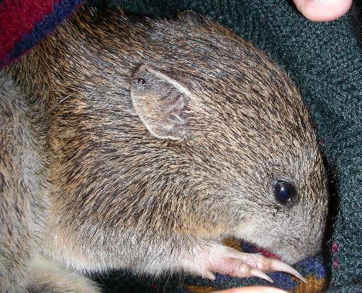
Figure 12: Female Southern Brown Bandicoot with ear biopsy taken from right ear. Source: ForestrySA (2007)
ForestrySA trapping surveys have also resulted in the capture of Southern Brown Bandicoots from 2003-2009. Trapping effort was coordinated by Troy Horn and Rob Mengler, with assistance from TAFE groups at different times since 2006 (Error! Reference source not found.). The results from these trapping surveys augment the data from the regular digging abundance monitoring events detailed above (Figure 14).
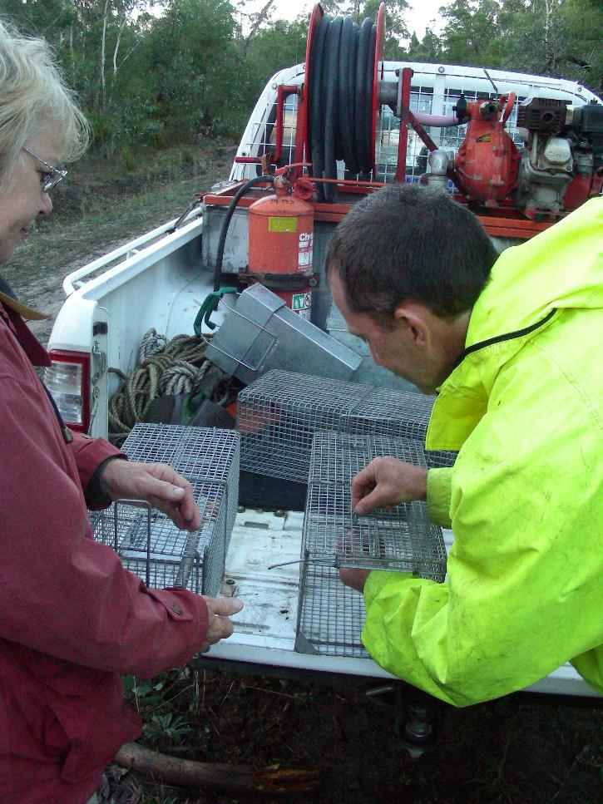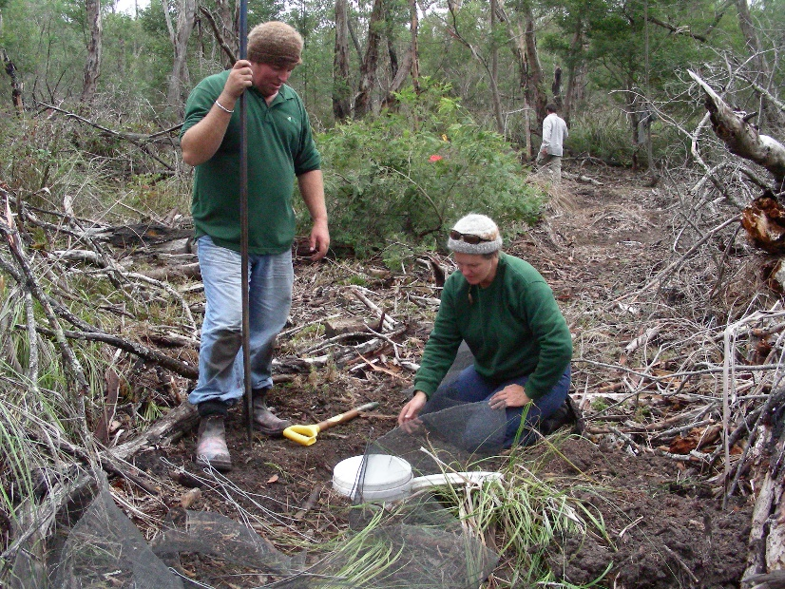
Figure 13: Conservation and Land Management students from SE TAFE setting up a trapping line in Kangaroo Flat NFR in 2007, with assistance from Rob Mengler (FSA) (Source: ForestrySA).

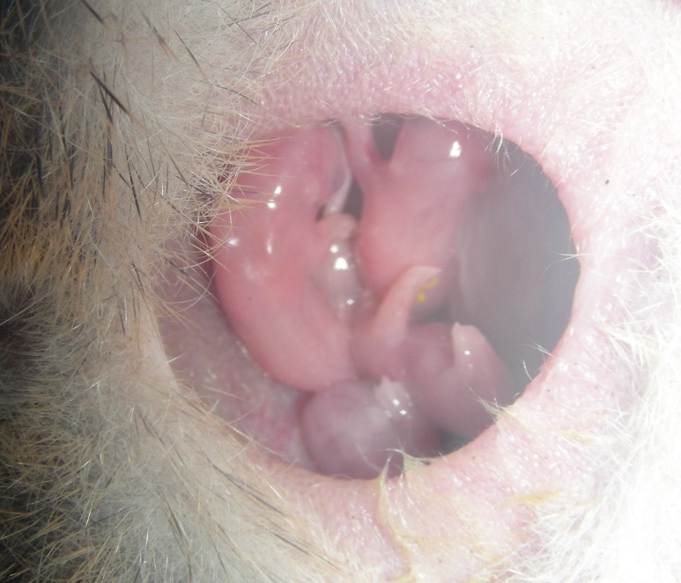
Figure 14: Southern Brown Bandicoot pouch young from one of the breeding females caught during the ForestrySA survey in 2007 (Source: ForestrySA).
Li et al. (2016) also collected samples and reported that the SE population forms part of the Mount Gambier to Portland sub-population (Paull, Mills and Claridge, 2013) and is distinctively different from the Mount Lofty Ranges and Kangaroo Island sub-populations (Li et al. 2015). As a result of this recent work, genetic experts espouse the potential on-ground benefits of translocations and encourage them if deemed necessary to ensure the maintenance of genetic variability in populations. Other recommendations included to continue to develop habitat corridors and support the retention and restoration of native vegetation to extend and improve suitable habitat.

Table 8: Summary of Southern Brown Bandicoot captures and ear biopsies provided to genetic studies from 2001-2007
Genus | Species | Sex | Tissue | Locality | State | Zone | Easting | Northing | Collector | Date
Isoodon | obesulus | m | Ear | Dry Creek NFR (Wild Dog) | SA | 54 | 495300 | 5798800 | Mark Bachmann | 19/10/2002
Isoodon | obesulus | f | Ear | Grundys Lane NFR | SA | 54 | 478787 | 5826631 | Mark Bachmann | 24/04/2001
Isoodon | obesulus | f | Ear | Grundys Lane NFR | SA | 54 | 477324 | 5826707 | Mark Bachmann | 24/04/2001
Isoodon | obesulus | f | Ear | Grundys Lane NFR | SA | 54 | 478787 | 5826631 | Mark Bachmann | 25/04/2001
Isoodon | obesulus | m | Ear | Grundys Lane NFR | SA | 54 | 478163 | 5826613 | Mark Bachmann | 26/04/2001
Isoodon | obesulus | f | Ear | Grundys Lane NFR | SA | 54 | 478127 | 5826581 | Mark Bachmann | 27/04/2001
Isoodon | obesulus | m | Ear | Hacket Hill NFR | SA | 54 | 470694 | 5830433 | Mark Bachmann | 26/04/2001
Isoodon | obesulus | m | Ear | Hacket Hill NFR | SA | 54 | 470269 | 5830206 | Mark Bachmann | 27/04/2001
Isoodon | obesulus | f | Ear | Hacket Hill NFR | SA | 54 | 470679 | 5830420 | Mark Bachmann | 27/04/2001
Isoodon | obesulus | f | Ear | Hacket Hill NFR | SA | 54 | 470580 | 5830820 | ForestrySA | 8/05/2007
Isoodon | obesulus | f | Ear | Honan NFR | SA | 54 | 465625 | 5823450 | Dan Harley, Troy Horn | 16/11/2004
Isoodon | obesulus | f | Ear | Honan NFR | SA | 54 | 465400 | 5823550 | Dan Harley, Troy Horn | 16/11/2004
Isoodon | obesulus | m | Ear | Honan NFR | SA | 54 | 465120 | 5823400 | Dan Harley, Troy Horn | 17/11/2004
Isoodon | obesulus | f | Ear | Honan NFR | SA | 54 | 465120 | 5823400 | Dan Harley, Troy Horn | 18/11/2004
Isoodon | obesulus | f | Ear | Honan NFR | SA | 54 | 465625 | 5823450 | Dan Harley, Troy Horn | 18/11/2004
Isoodon | obesulus | m | Ear | Honan NFR | SA | 54 | 465120 | 5823400 | Dan Harley, Troy Horn | 18/11/2004
Isoodon | obesulus | f | Ear | Honan NFR | SA | 54 | 465625 | 5823450 | Dan Harley, Troy Horn | 19/11/2004
Isoodon | obesulus | f | Ear | Honan NFR | SA | 54 | 465625 | 5823450 | Dan Harley, Troy Horn | 19/11/2004
Isoodon | obesulus | f | Ear | Honeysuckle NFR | SA | 54 | 493727 | 5797330 | Troy Horn, FSA | 19/04/2004
Isoodon | obesulus | f | Ear | Kangaroo Flat NFR | SA | 54 | 470210 | 5826341 | ForestrySA | 23/09/2006
Isoodon | obesulus | f | Ear | Kangaroo Flat NFR | SA | 54 | 470210 | 5826341 | ForestrySA | 25/09/2006
Isoodon | obesulus | m | Ear | Long NFR | SA | 54 | 461254 | 5828157 | Troy Horn, FSA | 25/05/2005
Isoodon | obesulus | m | Ear | Long NFR | SA | 54 | 461254 | 5828157 | Troy Horn, FSA | 27/05/2005
Isoodon | obesulus | f | Ear | Lower Glenelg River CP | SA | 54 | 497183 | 5794651 | Mark Bachmann | 13/06/2001
Isoodon | obesulus | m | Ear | Lower Glenelg River CP | SA | 54 | 497139 | 5794594 | Mark Bachmann | 13/06/2001
Isoodon | obesulus | m | Ear | Lower Glenelg River CP | SA | 54 | 497117 | 5794553 | Mark Bachmann | 13/06/2001
Isoodon | obesulus | f | Ear | Lower Glenelg River CP | SA | 54 | 497035 | 5794380 | Mark Bachmann | 11/12/2001
Isoodon | obesulus | m | Ear | Lower Glenelg River CP | SA | 54 | 497088 | 5794526 | Mark Bachmann | 27/11/2002
Isoodon | obesulus | f | Ear | Lower Glenelg River CP | SA | 54 | 497166 | 5794654 | Mark Bachmann | 24/06/2004
Isoodon | obesulus | m | Ear | Lower Glenelg River CP | SA | 54 | 497098 | 5794503 | Mark Bachmann | 24/06/2004
Isoodon | obesulus | f | Ear | Lower Glenelg River CP | SA | 54 | 497166 | 5794654 | Mark Bachmann | 24/06/2004
Isoodon | obesulus | m | Ear | Lower Glenelg River CP | SA | 54 | 497166 | 5794654 | Mark Bachmann | 25/06/2004
Isoodon | obesulus | f | Ear | Lower Glenelg River CP | SA | 54 | 497166 | 5794654 | Mark Bachmann | 16/04/2005
Isoodon | obesulus | f | Ear | Lower Glenelg River CP | SA | 54 | 497183 | 5794651 | Mark Bachmann | 27/03/2006
Isoodon | obesulus | f | Ear | Lower Glenelg River CP | SA | 54 | 497041 | 5794341 | Mark Bachmann | 27/03/2006
Isoodon | obesulus | m | Ear | Lower Glenelg River CP | SA | 54 | 497092 | 5794519 | Mark Bachmann | 30/07/2007
Isoodon | obesulus | f | Ear | Lower Glenelg River CP | SA | 54 | 497166 | 5794654 | Mark Bachmann | 1/08/2007
Isoodon | obesulus | f | Ear | Lower Glenelg River CP | SA | 54 | 497153 | 5794642 | Mark Bachmann | 3/08/2007
Isoodon | obesulus |  | specimen | Lower Glenelg River CP | SA | 54 | 497166 | 5794654 | Mark Bachmann | 1/08/2007
Isoodon | obesulus | m | Ear | McBain (private), Nangwarry | SA | 54 | 495548 | 5839559 | Mark Bachmann | 19/08/2003
Isoodon | obesulus | m | Ear | McBain (private), Nangwarry | SA | 54 | 495548 | 5839559 | Mark Bachmann | 20/08/2003
Isoodon | obesulus | f | Ear | McBain (private), Nangwarry | SA | 54 | 495548 | 5839559 | Mark Bachmann | 21/08/2003
Isoodon | obesulus | m | Ear | McRosties NFR | SA | 54 | 459076 | 5841617 | Troy Horn, FSA | 2/11/2003
Isoodon | obesulus | m | Ear | Mt Watch NFR | SA | 54 | 458300 | 5828998 | ForestrySA | 10/05/2007
Isoodon | obesulus | m | Ear | The Heath NFR | SA | 54 | 492734 | 5840587 | Mark Bachmann | 2/03/2004
Isoodon | obesulus | f | Ear | Windy Hill NFR | SA | 54 | 458201 | 5827079 | ForestrySA | 11/05/2007

Objective 4: Identify the key attributes of existing or potential habitat that are important for the Southern Brown Bandicoot
Action 1.2 - Monitor the condition and changes to critical habitat through time by establishing a series a permanent photo points and vegetation quadrats.

Permanent photo points and vegetation plots were established in NFR’s throughout the range of the Southern Brown Bandicoots, between 2006 and 2013 and by ForestrySA staff, for the purpose of describing vegetation communities and providing long-term, baseline vegetation data not initially with Southern Brown Bandicoot conservation in mind. Despite this, these monitoring sites will provide essential information on temporal changes in habitat condition (occurring through impacts such as weed invasion, prescribed burns or bushfires and climate change).
During the implementation of the revised RAP this action should remain but be revised to target future translocations and assisting in monitoring success of on-ground activities.

Objective 6: Build a network of government and non-government organisations and individuals to facilitate recovery of the Southern Brown Bandicoot
and
Objective 8: Promote public awareness of and involvement in the Southern Brown Bandicoot recovery program
The ForestrySA Biodiversity Corridors Strategy was implemented in 2005 and aims to link together NFRs located within the plantation matrix with revegetation, in order to address fragmentation issues for species such as the Southern Brown Bandicoot, Heath Mouse, and Yellow-bellied Glider. An extensive program of restoration and community involvement (especially school programs) has taken place since the programs establishment, and continues at the present time (see information provided under Objective 2 above).
Action 10 - Establish a regional South East Southern Brown Bandicoot Recovery Team comprised predominantly of regional DEHSA and ForestrySA biodiversity officers. The South East Southern Brown Bandicoot Recovery Team should meet twice per year to review the development and implementation of management actions
A regional recovery team has never been established, largely due to issues with staff impermanence and ownership of RAP implementation. Despite this, informal yet effective communication between major stakeholders since the development of the 2006 RAP has ensured good liaison between DEWNR and ForestrySA over the past decade.
This action is still considered worthy and will be retained in the revised RAP, with a greater emphasis on custodianship and stakeholder communication (i.e. ForestrySA, DEWNR, NRSE, OFO, NGT, Field Naturalists, and Adelaide Mount Lofty Ranges NRM).
Action 11 - Information on bandicoot distribution and abundance should be provided to Sharn Lucas, the South East’s biodiversity officer responsible for corridor establishment. Opportunities to enhance connectivity between fragmented populations should be highlighted.
This action was considered irrelevant as this position was made redundant early on in the RAPs period of operation. However, all Southern Brown Bandicoot related data must continue to be captured into the SA BDBSA database to highlight opportunities for collaboration and to target key sites and management actions.
Action 14 - Maintain regular contact with Kirstin Long, the Southern Brown Bandicoot Project Officer in the Mount Lofty Ranges.
Staff impermanence in the SE region and Mount Lofty region, has meant that this action has not been adequately achieved over the 2006-16 period. This action is still considered worthy and will be retained in the revised RAP, with a greater emphasis on custodianship and stakeholder communication.

Objective 7: Manage and review Recovery Plan implementation
Action 9 - Data management:
Three databases should be established to capture the following information:
            - all bandicoot surveys in the SE region
            - fox baiting programs at sites where the species has been recorded
            - fire history of sites where bandicoot have been recorded and a list of prescribed burns proposed for these patches.
Minimum data requirements should be specified for all future activities falling into each of these categories.
ForestrySA and DEWNR contain databases which hold information on Southern Brown Bandicoot surveys, fox baiting and/or fire history for all known bandicoot population reserves. However, no coordinated approach exists which captures all of this information in one system.
An Excel spreadsheet has been created to capture all digging abundance survey data aligned with date of last burn for each compartment with a known fire history. The inclusion of fire history for private land sites is a gap in our knowledge, albeit can be assumed to be long unburnt (>35yrs, possibly pre Ash Wednesday 1983).
It is important to maintain the current datasets to track the history of managing sites and monitoring and for this data to be used in reporting on an a needs basis (for example: Bachmann & Fullagar, 2017). However coordinating all of this information is the responsibility of the custodian of the RAP, not the land managers. Understanding how all of this data could be incorporated into BDBSA is a gap.
Action 16 - Participate in meetings of the National Southern Brown Bandicoot Recovery Team.
A National Recovery Team has not been established (M Bachmann, pers. comm, 2017). Due to staff impermanence in the SE region, this action has not been achieved. Participation in any SA or National Recovery Teams is not seen as a high priority however this action should be retained in the revised RAP for future consideration and involvement. Despite no recovery team existing, ForestrySA have the ecological trained staff and support from local environmental organisations (NGT and NRSE) to address concerns regarding Southern Brown Bandicoot conservation and habitat management.
Objective 9: Assess the requirement for captive populations
There were no actions included in the 2006 RAP related to this NRP objective. However, there was mention of potential translocations in the longer-term, particularly to sites where bandicoots appear to have become locally extinct such as Lake Leake and Brooksbys. This has also been supported by recent genetics research undertaken by Li et al. (2016).

4.2 Summary of achievements and gap analysis
The SE region makes a significant contribution towards Southern Brown Bandicoot conservation as described in Section 4.1. Small mammal surveys and research have been undertaken to confidently ascertain that there are three core extant populations (west of the Glenelg River) with potential (albeit unlikely) for more in the mid-SE.
Impacts of bushfires are evident in the results from the digging abundance surveys from 2016 where three sites known to have bandicoots previously, currently had no records of bandicoots after being totally burnt. This highlights the importance of connectivity and the need to facilitate re-colonisation.
Bandicoot digging abundance surveys in 2007-08 and 2016 are key achievements in monitoring patch occupancy and digging activity levels of Southern Brown Bandicoots in key populations and provide the ability to extrapolate to make inferences regarding the health of core populations. Currently the occupancy of patches over all core populations remains stable. Digging activity however, in Mt Burr Range core population is stable, and in Nangwarry and Caroline core populations it is declining (Bachmann & Fullagar, 2017).
Key achievements and priority gaps identified during the review process are outlined in the sections below (in line with NRP objectives). A tabulated summary of the review undertaken in Section 4.1 is presented in Appendix 3 for ease of identifying gaps and informing the development of the revised action table in Section 5.
Habitat management and protection
NFRs are subject to prescribed burn plans and ForestrySA promote 25-30 year burn cycles for large reserves. Burn plans are consistent with bandicoot requirements. Although fire impacts Southern Brown Bandicoot habitat, any impairment seems to be short-term, with most populations seeming to recover fully in 6-8 years post fire. Weed control has taken place at a selection of Southern Brown Bandicoot sites during the review period by ForestrySA as part of their annual woody weed management program. Volunteers assist with the delivery of this program. This is an ongoing action required to reduce the impact of weeds on habitat structure.
Track rationalisation has occurred in many of the reserves supporting bandicoots, which has led to improved connectivity of patches. Regional introduced predator control (by ForestrySA and DEWNR) is also routinely undertaken in habitats supporting Southern Brown Bandicoots. Fox control is undertaken at the majority of known Southern Brown Bandicoot sites in SE SA. Currently feral cats are not the focus of predator control programs. Control programs for foxes should continue however be reviewed in light of predator discussion in Bachmann and Fullagar (2017), and investigation towards understanding the impacts of feral cats worth exploring with neighbours to reserves. Advice for landholders wishing to manage habitat for bandicoots is warranted.

Population distribution and abundance/ habitat monitoring
The presence and absence of bandicoots has been routinely monitored since 1998 at many NFRs (typically using digging abundance surveys). Digging activity, which involves the physical counting of evidence of the amount of feeding behaviour taking place within (372, 1ha sites) representative areas of native vegetation in the lower South East, as a surrogate measure of bandicoot abundance, has declined. Occupancy, which is the detected presence of I. obesulus digging activity within these patches, remains stable.
Monitoring 372 digging abundance sites is a worthwhile but massive undertaking every 8-10 yrs. The 8-10 year gap between monitoring events may potentially be too long a time period to confidently capture changes occurring at small, isolated populations. Potentially, populations that are small and isolated could be lost between monitoring periods. An interim measure of presence-absence surveys is recommended for consideration in the future monitoring framework to address this need.
Permanent photo point and vegetation plot monitoring have been established in NFRs supporting Southern Brown Bandicoots to provide baseline information and track changes in habitat over time. The spread of sites is not adequately covering all core populations and should be improved during the implementation of the next RAP. Data indicates that Acacia longifolia and Pinus radiata are present in XX% of sites.
Extension and community education
In order to implement the RAP, DEWNR (NRSE) and its partners will need to continue to liaise closely with ForestrySA and OneFortyOne Plantations for support to ensure continuation of the establishment of biodiversity corridors and the associated school based education program. Additional communication with landholders will be required in the revised RAP to ascertain if a population exists near Lucindale, and with Glenelg Ark to establish the results of broad scale predator control near the Caroline Forest. The SE region could support the development of a regional recovery team to facilitate communication and/or continue liaison with experts at the national scale with national recovery team representation.
Translocations and captive breeding
Improving connectivity between remnants is a high priority action from a national perspective. The SE region is fortunate to have commenced this process before the turn of the century, placing us in a unique situation in that we are already some distance down the road to re-linking populations with areas of natural vegetation. However, in the short to medium term, the possibility of losing populations while we wait for the establishment of all corridors to be complete, or indeed to retain the genetic integrity of populations even with corridors, may require intervention. In these situations, supplementation of populations with translocated individuals may be necessary.

Gaps and recommendations
The 2006 RAP review identified the following as key gaps and recommendations to be considered in the revised 2017 RAP:
  - mapping potential habitat throughout the SE region, particularly the mid SE
  - develop and implement a future monitoring framework for declining populations
  - promotion of results from digging abundance surveys in local media
  - encourage the continuation of the school-based biodiversity corridor education program
  - investigate captive breeding population options and translocation feasibility
  - encourage further exploration of the effectiveness of fox control programs and/or trial release/re-introduction of alternative apex marsupial predators

REVISED SOUTH EAST REGIONAL ACTION PLAN

5.1 Goal and objectives
The overarching goal of the RAP is to identify and prioritise the threat abatement actions necessary to conserve the three core populations (plus any additional sites) of Southern Brown Bandicoot present in the SE of SA. The key steps to achieving this involve the implementation of appropriate in situ management actions, primarily habitat management and predator control, to protect and expand the remaining core populations.
The overarching RAP recovery target remains:
Recovery Target
- over the next two decades, ensure the persistence of bandicoot populations at a minimum of 2 remnant patches of native vegetation in the Caroline Forest, 2 remnants in Nangwarry Forest and in 18 remnants on the Mt Burr Range.

Objectives for the period from 2017 to 2027 are to:
- continue to contribute to the state and national recovery of the Southern Brown Bandicoot
- provide an update on the current distribution, abundance and trajectory of Southern Brown Bandicoot populations in the SE region that can be used to inform management actions
- re-assess the threats to the immediate persistence of Southern Brown Bandicoot in declining populations and propose appropriate conservation responses
- identify and prioritise a list of on-ground works and other actions for implementation to mitigate the impact of threats to the persistence of Southern Brown Bandicoot at key sites in the SE
- align SE RAP management actions with key national and state level policy documents for the species (e.g. draft NRP, Action Plan for Australian Mammals, and Australian Government Conservation Advice).

5.2 Revised actions 2017 to 2027
The following table details the actions to be implemented over the next ten years for Southern Brown Bandicoot conservation in the SE NRM region. The table is set out using objectives as outlined in draft National Recovery Plan (Brown and Main 2010), with regional actions for those aspects considered relevant.
Performance indicators, key inputs (and in some instances monitoring mechanisms), as well as assumptions, responsibility and timeframe, are provided for each SE RAP action. Actions are given a priority status (red=high priority; orange=moderate priority; yellow=low priority) and RCT and MAT references are included in order to link the RAP actions to the SE NRM Plan (2010) for reporting and investment purposes. Actions coloured in green are considered either underway or ongoing.
Monitoring the achievement of RAP actions often involves the collection of baseline data at the commencement of the plan and data at the completion of the plan. Other aspects of monitoring RAP implementation will require the annual obtainment and analysis of data.
The 2017-27 RAP should be reviewed in its entirety in 2027-28, in line with the review and revision process outlined in Section 1.3.

NRP objective | SE RAP actions |  | Performance indicator | Key inputs/monitoring mechanisms | Assumptions | Priority | Responsibility | Timeframe | RCT and MAT reference
1. Ensure that existing bandicoot populations and their habitat are protected and managed
 | 1 | Undertake site-based habitat management works at localities supporting extant populations of bandicoots. | Number of cpts treated, hectares of weeds removed | Action plans prepared, and works prioritised. | Reducing weed cover improves Southern Brown Bandicoot habitat |  | Lead:  ForestrySA  Others:  DEWNR (NRSE)  Landholders | Ongoing  2017-2027 | RCT B.1 & B.3  MAT A.1, A.5, A.9, D.6 & D.12
 | 2 | Protect and enhance the habitat and food resources available to bandicoots through the implementation of appropriate burning regimes. Support DEWNR and ForestrySA during implementation and review of their prescribed burning programs. | ForestrySA and NRSE acknowledge request in respective burn plans | Annual burn plans  Flora plots and photopoints  Population monitoring protocol | Bushfire impacts on Southern Brown Bandicoot habitat.  Recommendations from Bachmann & Fullagar (2017) are able to inform future burn regimes and protect Southern Brown Bandicoot populations/habitat. |  | Lead:  ForestrySA  Others:  DEWNR (NRSE)  Landholders | Ongoing  2017-2027 | RCT B.1 & B.3  MAT A.1, A.5, A.9, A.15
 | 3 | Implement long-interval fuel reduction burns (≥ 15 years) at strategic localities to minimise the risk of wildfire destroying large areas of bandicoot habitat. | ForestrySA and NRSE acknowledge request in respective burn plans | Annual burn plans  Fire history datasets  Scientific Reference Areas | Bushfire impacts on Southern Brown Bandicoot habitat.  Recommendations from Bachmann & Fullagar (2017) are able to inform future burn regimes and protect Southern Brown Bandicoot populations/habitat. |  | Lead:  ForestrySA  Others:  DEWNR (NRSE) | Ongoing  2017-2027 | RCT B.1 & B.3  MAT A.1, A.5, A.9, A.15
 | 4 | Control invasive plants, particularly woody weeds to reduce the impact on habitat structure. Target weeds to include Pine, Sallow Wattle, Coastal Wattle, Bridal Creeper, Sweet Pittosporum, Horehound, Cotoneaster and Polygala. | Key weed species determined, mapped and prioritised | Field observations  FSA/DEWNR weed database records | Key weed species can be easily identified and impacts determined via indirect measures |  | Lead:  ForestrySA  Others:  DEWNR (NRSE) | Ongoing  2017-2027 | RCT B.1 & B.3  MAT A.1, A.5, A.9, A.15
2. Identify threats and threat abatement management practices to assist the recovery of the Southern Brown Bandicoot
 | 5 | Identify opportunities to reduce the number of tracks bisecting Southern Brown Bandicoot habitat | Number of patches and tracks rationalised | Patches prioritised | Reducing tracks through habitat improves Southern Brown Bandicoot recovery |  | Lead:  ForestrySA  Others:  Landholders | Ongoing  2017-2027 | RCT B.1 & B.3  MAT A.1, A.5, A.9, B.1 & D.6
 | 6 | Quantify impacts of fire on the status of the species in Glencoe Hill, Mount Watch and Dry Creek NFRs, at 6 yrs post fire. | Evidence of re-colonisation | Population monitoring protocol  Photopoints | Re-colonisation of Southern Brown Bandicoot population post-fire is expected |  | Lead:  DEWNR (NRSE)  Others:  ForestrySA | 2019-21 | RCT B.1 & B.3  MAT A.1, A.5, A.9, A.10
 | 7 | Continue introduced predator control programs (foxes) at sites supporting extant bandicoot populations. Increase effort pre and post fire. Increase understanding of predation threat by cats. | Predator control program continued in key Southern Brown Bandicoot habitat | Declining population protocol  Prescribed burning program schedule  Bait stations and frequency identified | Control methods appropriate.  Reducing predator numbers improves Southern Brown Bandicoot recovery |  | Lead:  ForestrySA  Others:  DEWNR (NRSE)  Parks Victoria  DELWP  Glenelg Ark Project  Landholders | Ongoing  2017-2027 | RCT B.1 & B.3  MAT A.1, A.5, A.9, A.14, B.1, C.2, C.8 & D.6
3. Determine the distribution, abundance and population structure of the Southern Brown Bandicoot; and
5. Evaluate population responses of the Southern Brown Bandicoot to recovery actions, and adapt actions as required
 | 8 | Determine the abundance of bandicoots at all sites where the species has been recorded previously to assess the condition of all extant populations in the region. Retain existing digging abundance sites and repeat every 10 years. | All patches surveyed and occupancy determined | New and existing sites identified  Methodology updated | Number of occupied sites increases over time. |  | Lead:  DEWNR (NRSE)  Others:  ForestrySA | Ongoing  2017-2027 | RCT B.3  MAT A.9, B.4, D.6 & D.12
 | 9 | Determine presence/absence of the species in patches which have not been adequately searched/verified including Aslins, Brooksbys, Lake Leake, Maxwell, The Bluff, Gower CP, Penambol CP, Warreanga and private land sites near Lucindale. | Number of patches surveyed/clarified. | New monitoring sites established. | Access to private land sites granted.  Number of occupied sites increases over time. |  | Lead:  DEWNR (NRSE)  Others:  ForestrySA | 2017-19 | RCT B.1 & B.3  MAT A.1, A.5, A.9, B.1 & D.6
 | 10 | Develop a standard, optimal protocol for monitoring bandicoot occupancy between large scale (every 10yr) survey periods. This technique must have sufficient power to reliably detect temporal changes in the species’ abundance at a site over short timeframes. It must include pre and post fire monitoring, criteria for addressing declining populations, and for triggering investigations into translocation. | Protocol developed involves a rapid assessment and is available for field use in 2 years. | Abundance determined per patch at existing or new sites. | Protocol collects information required to inform management of declining key patches and/or core populations. |  | Lead:  DEWNR (NRSE)  Others:  ForestrySA | 2017-18 | RCT B.3  MAT A.5, A.9, B.4, & D.12
 | 11 | Genetic samples (ear biopsies) should continue to be collected from bandicoots in the South East to assist with investigations into population fragmentation. Adapt bandicoot management strategies if and when new information arises. | Genetic material collected from fragmented and connected populations in SE SA.  Genetic status and connectivity between sub-populations identified. | Tissue samples and analysis | Tissue samples collected are effective in determining the connectivity of sub-populations. |  | Lead:  DEWNR (NRSE)  Others:  ForestrySA | Ongoing  2017-2027 | RCT B.3  MAT A.9, A.10, D.6 & D.12
4. Identify the key attributes of existing or potential habitat that are important for the Southern Brown Bandicoot
 | 12 | Map potential habitat throughout the region, including the mid SE. | Update vegetation communities | Existing flora plot network (BDBSA)  Existing vegetation layer accuracy | Improving knowledge about habitat suitability increases Southern Brown Bandicoot recovery |  | Lead:  DEWNR (NRSE)  Others: | 2017-19 | RCT B.1 & B.3  MAT A.1, A.5, A.9, B.1, & D.6
 | 13 | Monitor the condition and changes to critical habitat through time using established permanent photo points and vegetation quadrats. Target monitoring of post fire, weed control effort and translocation sites. | Translocation plan  No. of plots per core population | Translocation plan  Existing flora plot network (BDBSA/FSA)  Weed control and prescribed burning program outputs | Improving knowledge about habitat condition increases Southern Brown Bandicoot recovery |  | Lead:  DEWNR (NRSE)  Others:  ForestrySA | Ongoing  2017-2027 | RCT B.1 & B.3  MAT A.1, A.5, A.9, A.10, A.14, B.1, C.2, C.8 & D.6
6. Build a network of government and non-government organisations and individuals to facilitate recovery of the Southern Brown Bandicoot; and
8. Promote public awareness of and involvement in the Southern Brown Bandicoot recovery program
 | 14 | Establish a regional South East Southern Brown Bandicoot Recovery Team comprised predominantly of regional DEWNR and ForestrySA biodiversity officers. Nominate a lead custodian for RAP implementation whose role it is to facilitate communication between stakeholders. | All key stakeholders represented | Communication records  Key contact information | Lead custodian has funding to convene recovery team.  Regular liaison between ForestrySA and NRSE will occur in the absence of a formal communication arrangement. |  | Lead:  DEWNR (NRSE)  Others:  ForestrySA  OFO  NGT  Field Nats  AMLR | 2017-19 | RCT B.3  MAT A.9, B.4 & D.7
 | 15 | Promote results of digging abundance surveys in local media. | Two communications post report release | Summary report containing information relating to all patches/core populations. | Public awareness raising activities contribute to Southern Brown Bandicoot recovery |  | Lead:  DEWNR (NRSE)  Others: | Ongoing  2017-2027 | RCT B.3  MAT B.4
 | 16 | Encourage the continuance of school based biodiversity corridor education program. | Three local schools maintain involvement in growing and planting native species into corridors | Funding for SSO support and liaison with schools | Establishment continues under ForestrySA/OFO agreement. Establishment of |  | Lead:  ForestrySA  Others:  DEWNR (NRSE) | Ongoing  2017-2027 | RCT B.1 & B.3  MAT A.1, A.5, A.9, A.10, B.2-4, & C.8
 | 17 | Develop advice statements for landholders wishing to manage suitable habitat for Southern Brown Bandicoots. Provide a relevant contact for landholders. | Number of statements provided, field days attended/communications | Funding available to support development of information | NRSE Officer is main contact |  | Lead:  DEWNR (NRSE)  Others: | 2017-19 | RCT B.1 & B.3  MAT A.1, A.5, A.9, B.1 & D.6
 | 18 | Information on bandicoot distribution and abundance should be captured in relevant stakeholder databases and regularly uploaded into the state BDBSA database. | All data collated and verified | Templates provided for data transfer | All data entered into BDBSA |  | Lead:  DEWNR (NRSE)  Others:  ForestrySA | Ongoing  2017-2027 | RCT B.3  MAT A.9 & D.3
7. Manage and review NRP implementation
 | 19 | Data management – maintain databases developed to capture bandicoot surveys, fox baiting programs and fire history. | Data capture protocols developed/updated | Field based, GIS and fire history data capture streamlined | Databases maintained and updated accordingly. |  | Lead:  ForestrySA  Others:  DEWNR (NRSE) | Ongoing  2017-2027 | RCT B.3  MAT A.9 & D.3
 | 20 | Participate in meetings of the National Southern Brown Bandicoot Recovery Team. Nominate representative/s. | Record (and store) evidence of communications /partnerships between organisations and states | Communication records  Key contact information | Regular liaison between SA regions and Vic will occur in the absence of a formal communication arrangement. |  | Lead:  DEWNR (NRSE)  Others: | Ongoing  2017-2027 | RCT B.3  MAT A.9, D.7 & D.12
9. Assess the requirement for captive populations
 | 21 | Investigate the potential for translocation of bandicoots to sites where they appear to be extinct or close to local extinction with little chance of natural re-colonisation. | Translocation plan | Translocation plan  Digging abundance data | Translocating Southern Brown Bandicoots to existing and other areas of suitable habitat is an effective way to recover the species in the SE region. |  | Lead:  DEWNR (NRSE)  Others: | 2017-19 | RCT B.1 & B.3  MAT A.1, A.5, A.9, B.1 & D.6

REFERENCES
Bachmann, M. and Fullagar, A. (2017). Surveys of Digging Abundance of the Southern Brown Bandicoot (Isoodon obesulus) in the South East of South Australia: 1998 – 2016. Report to Department of Environment, Water and Natural Resources, Government of South Australia. Nature Glenelg Trust, Mount Gambier, South Australia.
Barnes, A. and Gemmell, R.T. (1984). Correlations between breeding activity in the marsupial bandicoots and some environmental variables. Australian Journal of Zoology 32: 219–226.
Braithwaite, R.W. (1995). Southern Brown Bandicoot Isoodon obesulus. Pp 176–177 in The Mammals of Australia ed by R. Strahan. Reed Books: Sydney.
Brown, G.W. (2004). National Recovery Plan for Southern Brown Bandicoot Isoodon obesulus obesulus (Shaw, 1797) 2005 – 2009. Arthur Rylah Institute for Environmental Research, Department of Sustainability and Environment, Melbourne.
Brown, G.W. and M.L. Main (2010). Draft National Recovery Plan for the Southern Brown Bandicoot Isoodon obesulus obesulus. Department of Sustainability and Environment. Victoria, Department of Sustainability and Environment.
Claridge, A.W., McNee, A., Tanton, M.T. and Davey, S.M. (1991). Ecology of bandicoots in undisturbed forest adjacent to recently felled logging coupes: a case study from the Eden Woodchip Agreement Area. Pp. 331–345 in Conservation of Australia’s Forest Fauna ed by D. Lunney. Royal Zoological Society of New South Wales, Mosman.
Claridge, A.W., Paull, D.J. and Barry, S.C. (2010). Detection of medium-sized ground-dwelling mammals using infrared digital cameras: an alternative way forward? Australian Mammalogy 32 (2): 165-171.
Cooper, M.L. (2000). Random amplified polymorphic DNA analysis of southern brown bandicoot (Isoodon obesulus) populations in Western Australia reveals genetic differentiation related to environmental variables. Molecular Ecology 9: 469–479.
Department of Environment and Heritage (2010), Fire Management Plan: reserves in the South East 2010-2020. DEH - Mt Gambier.
Department of the Environment (2017). Isoodon obesulus obesulus in Species Profile and Threats Database, Department of the Environment, Canberra.DEC (2005). Draft Recovery Plan for the Southern Brown Bandicoot (Isoodon obesulus). NSW Department of Environment and Conservation, Hurstville.
Dickson, C. R. & Rajic, T. (2009) Regional Action Plan for Prasophyllum frenchii in the South East of South Australia. South Australian Department for Environment and Heritage, Mount Gambier.
Fearn E. K. G. & Johnson, R. (2010) Updated Regional Action Plan for the Recovery of Sand Ixodia in the South East of SA. South Australian Department for Environment and Heritage, Mount Gambier.
ForestrySA (2011), Mount Gambier Forest Management Plan, ForestrySA, Mount Gambier, South Australia.
ForestrySA (2013), Manual For Prescribed Burning, ForestrySA, Mount Gambier.
Foulkes, J.N. and Heard, L.M.B. (2003). A Biological Survey of the South East South Australia 1991 and 1997. Department for Environment and Heritage, Adelaide.
Friend, J.A. (1990). Status of bandicoots in Western Australia. Pp. 73–84 in Bandicoots and Bilbies ed by J.H. Seebeck, P. R. Brown, R.L. Wallis and C.M. Kemper. Surrey Beatty and Sons: Chipping Norton.
Gillam, S. and Urban, R. (2011). Regional Species Conservation Assessment Project, Phase 1 Report: Regional Species Status Assessments, South East Region. Department of Environment and Natural Resources, South Australia.
Haby, N. and Long, K. (2005). Recovery Plan for the Southern Brown Bandicoot in the Mount Lofty Ranges, South Australia, 2004 to 2009. Department for Environment and Heritage, Adelaide.
Harley, D., Bachmann, M., Green, R. & Stratman, B. (2005) Regional Action Plans for the Recovery of Threatened Fauna in the South East of South Australia. South Australian Department for Environment and Heritage, Mount Gambier.
Harley, D. (2006) Recovery of Malleefowl (Leipoa ocellata) populations in the South East of South Australia. South Australian Department for Environment and Heritage, Mount Gambier.
Harley, D. & Le Duff, M. (2009) Regional Action Plan for the Malleefowl Leipoa ocellata in the South East of South Australia. South Australian Department for Environment and Heritage, Mount Gambier.
Harley, D. (2006). Recovery of Southern Brown Bandicoot (Isoodon obesulus) populations in the South East of South Australia. Department for Environment and Heritage, Conservation Programs – South East.
Herpich, M. & Lindsay, A. (2008), EWeedMAT Environmental weed management action tool: a guide to implementing a landscape scale environmental weed management tool. Department for Environment and Heritage, Mt Gambier, South Australia.
Hinchliffe, D. (2007) Regional Action Plans for the Senecio macrocarpus and Glycine latrobeana in the South East of South Australia. South Australian Department for Environment and Heritage, Mount Gambier.
Horn, T. (2003). South East Biodiversity Corridors Strategy. Planning for tomorrow’s Biodiversity. The Development of Biodiversity Corridors within Forest Reserves in the Green Triangle Region of South Australia. ForestrySA.
Johnson, R. (2005a) Conservation and Management of Threatened Flora on Roadsides in the Upper South East of SA. South Australian Department for Environment and Heritage, Mount Gambier.
Johnson, R. (2005b) Regional Action Plans for the Recovery of Threatened Flora and Ecological Communities in the South East of SA. South Australian Department for Environment and Heritage, Mount Gambier.
Johnson, R. & Fearn, E. K. G. (2009) Updated Regional Action Plans for Allocasuarina leuhmanii and Eucalyptus microcarpa in the South East of South Australia. South Australian Department for Environment and Heritage, Mount Gambier.
Kerr, G. D. & Bonifacio, R. S. (2009) Regional Action Plan for the Southern Bent-wing Bat Miniopterus schreibersii bassanii in the South East of South Australia. Department for Environment and Heritage.
Le Duff, M., Stratman, B., Harley, D. and Herpich, D. (2009) An Assessment of the Conservation Status of the Southern Brown Bandicoot (Isoodon obesulus) in the South East of South Australia. Department for Environment and Heritage, Mount Gambier, South Australia.
Li, Y., Cooper, S.J.B., Lancaster, M.L., Packer, J.G. and Carthew, S.M. (2016) Comparative Population Genetic Structure of the Endangered Southern Brown Bandicoot, Isoodon obesulus, in Fragmented Landscapes of Southern Australia. PLOS ONE,11:1-20.
Li, Y., Lancaster, M.L., Cooper, S.J.B., Taylor, A.C., and Carthew, S.M. (2015) Population structure and gene flow in the endangered southern brown bandicoot (Isoodon obesulus obesulus) across a fragmented landscape. Conservation Genetics 16 (2) 331-345.
Lobert, B. (1990). Home range and activity period of the Southern Brown Bandicoot (Isoodon obesulus) in a Victorian heathland. Pp. 319–325 in Bandicoots and Bilbies ed by J.H. Seebeck, P. R. Brown, R.L. Wallis and C.M. Kemper. Surrey Beatty and Sons: Chipping Norton.
Lobert, B. and Lee, A.K. (1990). Reproduction and life history of Isoodon obesulus in Victorian heathland. Pp. 311–318 in Bandicoots and Bilbies ed by J.H. Seebeck, P.R. Brown, R.L. Wallis and C.M. Kemper. Surrey Beatty and Sons: Chipping Norton.
Lunney, D. and Leary, T. (1988). The impact on native mammals of land-use changes and exotic species in the Bega district, New South Wales, since settlement. Australian Journal of Ecology 13: 67–92.
Menkhorst, P.W. (1995). Mammals of Victoria. Distribution, ecology and conservation. Oxford University Press, Melbourne.
Menkhorst, P. (2001). A Field Guide to the Mammals of Australia. Oxford University Press, Melbourne.
Menkhorst, P.W. and Seebeck, J.H. (1990). Distribution and conservation status of bandicoots in Victoria. Pp. 51–60 in Bandicoots and Bilbies ed by J.H. Seebeck, P.R. Brown, R.L. Wallis and C.M. Kemper. Surrey Beatty and Sons: Chipping Norton.
Paull, D.J. (1993). The distribution, ecology and conservation of the Southern Brown Bandicoot (Isoodon obesulus obesulus) in South Australia. MA Thesis, University of Adelaide, Adelaide.
Paull, D. (1995). The Distribution of the Southern Brown Bandicoot (Isoodon obesulus obesulus) in South Australia. Wildlife Research 22: 585–600.
Paull, D.J. (1999). A survey of the distribution and abundance of the Southern Brown Bandicoot in the south east of South Australia. Working paper 1999/1. School of Geography and Oceanography, University of New South Wales, Canberra.
Paull, D.J. (2004). Habitat Fragmentation and the Southern Brown Bandicoot Isoodon obesulus at Multiple Spatial Scales. Ph.D. Thesis, University of New South Wales, Canberra.
Paull, D. J., Mills, D. J. and Claridge, A. W. (2013). Fragmentation of the Southern Brown Bandicoot Isoodon obesulus: Unraveling Past Climate Change from Vegetation Clearing. International Journal of Ecology, Article ID 536524.
Pope, L., Storch, D., Adams, M., Moritz, C. and Gordon, G. (2001). A phylogeny for the genus Isoodon and a range extension for I. obesulus peninsulae based on mtDBA control region and morphology. Australian Journal of Zoology 49: 411–434.
Quin, D.G. (1988). Observations on the diet of the Southern Brown Bandicoot, Isoodon obesulus (Marsupialia: Peramelidae), in southern Tasmania. Australian Mammalogy 11: 15–25.
Rees, M. and Paull, D. (2000). Distribution of the southern brown bandicoot (Isoodon obesulus) in the Portland region of south-western Victoria. Wildlife Research 27: 539–545.
Sanderson, K.J. and Kraehenbuehl, J. (2006). Southern Brown Bandiccots Isoodon obesulus in Belair National Park. Australian Mammalogy 28: 147–152.
SENRM Board (2010). Regional Natural Resources Management Plan. South East Natural Resources Management Board, Mt Gambier.
Slater, S and Hammer, M (2009). Drought Response Plan for Nationally Listed Fishes of South East South Australia: Regional Action, Contingency and Long Term Recovery. Department for Environment and Heritage, South East region.
Sweeney, O. & Dickson, C. R. (2011) A Regional Action Plan for the Glenelg Spiny Freshwater Crayfish Euastacus bispinosus in the South East of South Australia. South Australian Department for Environment and Natural Resources, Mount Gambier.
Stoddart, D.M. and Braithwaite, R.W. (1979). A strategy for utilization of regenerating heathland habitat by the brown bandicoot (Isoodon obesulus; Marsupialia, Peramelidae). Journal of Animal Ecology 48: 165–179.
TSSC (2016). Conservation Advice: Isoodon obesulus (Southern Brown Bandicoot). Threatened Species Scientific Committee, EPBC Act 1999, Canberra.
Westerman, M. and Krajewski, C. (2000). Molecular relationships of the Australian bandicoot genera Isoodon and Perameles (Marsupialia: Peramelina). Australian Mammalogy 22: 1–8.
Woinarski, J., Burbidge, A & Harrison, P. (2014), The action plan for Australian mammals 2012. CSIRO Publishing, Melbourne.
Zengler, K.R., Eldridge, M.D.B. and Johnston, P.G. (2005). Phylogenetics, population structure and genetic diversity of the endangered southern brown bandicoot (Isoodon obesulus) in south-eastern Australia. Conservation Genetics 6: 193–204.

APPENDIX 1 Workshop participants

Workshop held at SES Training Room, Jubilee Highway East, Mt Gambier
on Tuesday May 30th 2017

Attendees:
Troy Horn (ForestrySA)
Abigail Goodman (NRSE)
Justin Cook (OFO)
David Pitts (DELWP)
Rosey Pounsett (Millicent Field Naturalists)
Sue Black (Millicent Field Naturalists)
Bryan Haywood (NGT) facilitator

APPENDIX 2 Digging abundance survey methodology (extract from Bachmann & Fullagar, 2017)

Digging abundance was used to measure presence (occupancy), distribution and level of activity within a patch and can also be used, indirectly, as a surrogate for bandicoot abundance (Paull 2003). Diggings provide a clear indication that the site is or was being used (within a period of months) by I. obesulus (Fairbridge et al. 2001) making it an efficient, non-intrusive alternative to trapping and handling. The diggings made by I. obesulus are conical, near vertical diggings with one spoil mound (dug between their hind legs). This usually makes them distinguishable from a range of other species including the echidna, swamp rat, bush rat, Australian raven, chough and European rabbit.
The Long-nosed Potoroo Potorous tridactylus also creates diggings that can be confused with I. obesulus, but in the South East have only been recorded co-habiting with I. obesulus in the Lower Glenelg River Conservation Park (adjacent to the Caroline Forest area, east of the Glenelg River – noting that at this location the river is a major geographical barrier to dispersal). Potorous tridactylus is otherwise considered extinct in South Australia (west of the Glenelg River), and so was not a confounding factor for the survey results.
The number of survey sites allocated per patch, were stratified in relation to patch area. Site occupancy and abundance was estimated by actively walking through each site to record and count I. obesulus diggings. Each site was a 100 x 100 m (1 ha) quadrat; the approximate minimum home range size (9 ha being the upper recorded limit) for the species (Paull 2003).
To ensure that the majority of each site was surveyed, the GPS “tracks” function was used. The level of activity at a site was determined by categorising diggings into age classes: fresh (<2 weeks), recent (2 weeks – 2 months), and/or old (>2 months). The number of diggings was estimated per 100m walked within the quadrat (Paull 2003), but as we were especially interested in confirming the presence/absence of I. obesulus we also estimated digging abundance for the entire 100 x 100 m. These counts were assigned into digging abundance score categories: 0 (0 diggings), 1 (1-5 diggings), 2 (6-20 diggings), 3 (21 -50 diggings) 4, (≥51 diggings).
Digging records were used to determine site occupancy and the proportion of a patch occupied, based on the number of sites per patch where I. obesulus was present. The percentage of sites occupied within a patch was compared to an earlier survey period by calculating the difference in site occupancy (e.g. proportion of sites occupied in 2016 – proportion of sites occupied in 2007/08, per patch), to determine whether patch occupancy had decreased, remained stable or increased in 2016 (Figure 2 & 3). Thresholds of ≥30% increase or ≥30% decrease were employed (assumed sufficient to account for uncertainty).
Suggested supplementary method, if the regular digging abundance method fails to detect the presence of bandicoots in a patch:
1. Drive around the perimeter and all internal tracks within the remnant patch, looking for large specimens or groves of Black Wattle (Acacia mearnsii).
2. If and when detected, GPS the location of the tree or grove, and note its characteristics (i.e. single large tree, patch of trees, etc.).
3. Walk around the tree(s) and search for evidence of bandicoot digging activity.
4. Classify digging abundance for the site, irrespective of its size, according to the same scoring categories used for the general survey method (i.e. 0, 1, 2, 3, 4).
5. Repeat method until a Black Wattle grove registers bandicoot activity, at which time that wider patch becomes ‘occupied’ and the supplementary survey can end.
6. If no Black Wattle Groves register bandicoot activity after all tracks have been driven, then the patch remains ‘unoccupied’ and can be more confidently considered vacant for the purposes of monitoring occupancy trends.

APPENDIX 3 Review summary
A tabulated summary of the review detailed in Section 4.1.

Implementation status code: green=complete, orange=partially complete, yellow=NA or not able to be reviewed, red=incomplete

NRP objective | SE RAP actions |  | Implementation status | Review comment | Recommendation
1. Ensure that existing bandicoot populations and their habitat are protected and managed
 | 1 | Undertake site-based habitat management works at localities supporting extant populations of bandicoots. |  | SA NFRs have an annual weed control program primarily aimed at wild pines and wattle. Summary of sites treated and hectares to be provided in final plan.  Mt Gambier Friends of Parks group have contributed over 650hrs of labour towards planting and weeding in occupied patches and/or biodiversity corridor sites (incl Gower, Telford Scrub CP, Penambol CP & Lower Glenelg River CP. |  | Retain – support DEWNR and FSA during implementation of their habitat management works programs.
 | 1.1 | Protect and enhance the habitat and food resources available to bandicoots through the implementation of appropriate burning regimes. |  | SA NFRs are subject to prescribed burn plans. ForestrySA have 25-30 year burn cycles for large reserves. At these ForestrySA managed sites, burn plans have been consistent with meeting the requirements of the Southern Brown Bandicoot. Southern Brown Bandicoot were considered in the development of the SE Fire Management Plan and have specific management strategies. Significance of fire to SBB populations is well understood. Fire may impact on breeding, movements and food resources in the short-term only. Wildfires have occurred in Glencoe Hill, Mount Watch and Dry Creek NFR’s during the period of the previous plan. Impacts to those sub-populations is yet to be certain however it is expected that SBB’s will recover by 6-8yrs post-fire. |  | Retain - support DEWNR and FSA during implementation and review of their prescribed burning programs. New action - Quantify impacts of fire on the status of the species in Glencoe Hill, Mount Watch and Dry Creek NFRs, at 6 yrs post fire.
 | 2 | Implement long-interval fuel reduction burns (≥ 15 years) at strategic localities to minimise the risk of wildfire destroying large areas of bandicoot habitat. |  | Long-interval prescribed burning is a FSA policy with scientific reference areas set aside for this exact purpose. Currently these areas can be found in 17 NFR's known to contain SBB. An update on this information will come from FSA soon and be aligned with the Dig Ab report. |  | Retain as a priority.
 | 1.3 | Control invasive plants, particularly woody weeds such as Coastal Wattle (A. longifolia var. sophorae) and Sallow Wattle (A. longifolia var. longifolia). |  | Extensive weed control works are undertaken in NFR’s through the annual woody weed program and have done since 2006. A database of compartments is maintained and used for developing each year's program. Volunteers through the Friends of Parks also remove woody weeds in NPWSA reserves such as Gower CP and Penambol CP. |  | Retain - reduce the impact of weeds on habitat structure. Target weeds to include Pine, Sallow Wattle, Coastal Wattle, Bridal Creeper, Sweet Pittosporum, Horehound, Cotoneaster and Polygala.
2. Identify threats and threat abatement management practices to assist the recovery of the Southern Brown Bandicoot
 | 12 | Identify opportunities to reduce the number of tracks bisecting the Native Forest Reserves managed by ForestrySA. |  | NFRs where track rationalisation occurred to close old tracks and to enlarge compartments included MA, MR, WA, HH, HO, KF, MM & WN. |  | Retain – re-word to continue this concept but not be specific to FSA, to any landholder.
 | 3 | A detailed plan for controlling introduced predators at sites supporting extant bandicoot populations should be developed. |  | A plan was not developed, however FSA and DEWNR have policies relating to predator control which were implemented during this period in reserves where SBB's occur. Development of a plan was considered un-necessary. However advice for landholders with SBB's could be provided. |  | Retain - re-word to cover the continuation of predator control activities especially pre and post fire and/or during the optimal time of year for effective control (which is??)
3. Determine the distribution, abundance and population structure of the Southern Brown Bandicoot; and
5. Evaluate population responses of the Southern Brown Bandicoot to recovery actions, and adapt actions as required
 | 4 | Clarify the species’ ongoing presence at sites where it has been detected since 1990. |  | Repeats of the digging abundance surveys has ensured this action was completed. Report from 2009 & 2016 (in prep). No pre or post fire monitoring protocol exists in SE Fire Man Plan for SBB. |  | Remove - refer to action 6
 | 15 | Determine whether the species still occurs at the outlying site west of Lucindale where it was hair-tubed in 1997 during the Biological Survey of the South East. |  | Refer to comments (actions 4 & 5). |  | Remove - refer to action 6
 | 5 | Develop a standard protocol for assessing bandicoot abundance in vegetation remnants, potentially using a combination of conventional trapping, digging transects, hair tubes and camera traps. This technique must have sufficient power to reliably detect temporal changes in the species’ abundance at a site. |  | Abundance of SBB is considered too difficult and unreliable as data to be used for population analyses. The preferred method is to retain the digging abundance survey sites and for this method to be repeated every 10 yrs. However for declining populations in small patches it was considered necessary to develop interim criteria/protocol to confirm presence/absence in a more rapid manner. Digging Abundance survey is effective but time consuming. |  | Retain - prepare optimal monitoring protocols for the SE region populations to include pre and post fire monitoring, criteria for addressing declining populations, and for triggering investigations into translocation.
 | 6 | Establish the abundance of bandicoots at all sites where the species has been recorded previously to determine the condition of all extant populations in the region. |  | Refer to comments (actions 4 & 5). |  | Retain - revise this action to reflect on repeating digging abundance method every 10 yrs. And to determine presence/absence in patches which have not been adequately searched including The Bluff, Gower CP and private land sites near Lucindale.
 | 6.1 | The size and distribution of bandicoot populations in the Caroline Forest. |  | Complete. Distribution determined in Fullagar and Bachmann (in prep). |  | Remove - captured in digging abundance reporting
 | 6.2 | Bandicoot abundance in Native Forest Reserve compartments reserved from prescribed burns. |  | Abundance data not available, however this can be checked using data from ForestrySA and digging abundance survey results. The FSA Management plans indicate whether a compartment is reserved from burning or not. Refer to Fullagar and Bachmann (in prep) |  | Remove - captured in digging abundance reporting
 | 6.3 | Re-survey of the six sites where Paull (2004) failed to detect diggings (Brooksby, Burr Slopes, Mt Lyon, Paltridges, The Bluff and Lake Leake). |  | Refer to comments (actions 4 & 5). It has been clarified if SBB occur in all of these patches. Refer to digging abundance reports |  | Remove - refer to action 6
 | 7 | Based on the abundance data collected (and certain landscape variables), identify core populations in the region that are critical to the species’ long-term conservation. |  | Abundance data not available, however core populations are determined. They include Mt Burr Range, Nangwarry and Caroline. Key populations within the core areas are MB = NW, HO, MA, & WA CA = HS, NA, HE/Byrnes |  | Remove
 | 8 | Identify a number of key populations on which to focus monitoring efforts (i.e. at a subset of the sites where Paull (1999) identified the species to persist in the region). |  | Monitoring effort is considered important over entire range and all patches. A subset of sites have not been selected. However sites showing continual decline will be treated differently in the new plan. |  | Refer to action 5
 | 13 | Genetic samples (ear biopsies) should continue to be collected from bandicoots in the South East to assist the ARC linkage project based at the University of Adelaide, which is using molecular techniques to investigate population fragmentation in the species across the region. |  | Studies reported back that SE population forms part of the MG to Portland sub-population and is distinctively different from the MLR and KI sub-populations. Genetic studies encouraged the investigation and potential on-ground benefits of translocations if deemed necessary to ensure maintenance of the genetic variability of populations as a result of their work. |  | Retain - re-word to be reflective of need to adapt if and when new information arises.
4. Identify the key attributes of existing or potential habitat that are important for the Southern Brown Bandicoot
 | 1.2 | Monitor the condition and changes to critical habitat through time by establishing a series a permanent photo points and vegetation quadrats. |  | Permanent photo points and vegetation plots have been established in NFR’s throughout the range of the SBB. These sites will provide baseline information in the event of changes in habitat condition occurring through weed invasion, prescribed or wildfires. |  | Retain – monitor plots after recovery from fires or weed control activities.
6. Build a network of government and non-government organisations and individuals to facilitate recovery of the Southern Brown Bandicoot; and
8. Promote public awareness of and involvement in the Southern Brown Bandicoot recovery program
 | 10 | Establish a regional South East Southern Brown Bandicoot Recovery Team comprised predominantly of regional DEHSA and ForestrySA biodiversity officers. |  | Not implemented as custodian of the RAP has lost key driver during period of the plan. Also, communication during 2006 RAP development has ensured good liaison between major stakeholders (DEWNR and FSA) during 2006-16 period. |  | Retain - however re-word to highlight the need for the custodian at the time of the next review should ensure communication between all stakeholders occurs. i.e.. FSA, DEWNR, NRSE, OFO, NGT, Field Nats, and AMLR
 | 11 | Information on bandicoot distribution and abundance should be provided to Sharn Lucas, the South East’s biodiversity officer responsible for corridor establishment. Opportunities to enhance connectivity between fragmented populations should be highlighted. |  | Not considered relevant as Sharn's position was lost early on during 2006-2016 period. |  | Remove. New action - ensure all data captured relating to SBB's is captured into BDBSA
 | 14 | Maintain regular contact with Kirstin Long, the Southern Brown Bandicoot Project Officer in the Mount Lofty Ranges. |  | Unsure if this occurred due to custodian of RAP changing hands and staff losses in NRSE. Also unsure of relevance now |  | Remove - refer to action 10
7. Manage and review NRP implementation
 | 9 | Data management – three databases should be developed to capture bandicoot surveys, fox baiting programs and fire history. |  | This action was complete. FSA and DEWNR contain databases which hold information on surveys, fox baiting and/or fire history for all SBB reserves |  | Retain - however re-word to reflect the need for maintenance of these databases rather than development. Refer to 11 below on capture of all data into BDBSA
 | 16 | Participate in meetings of the National Southern Brown Bandicoot Recovery Team. Nominate representative/s. |  | Not completed. Recovery Team is inactive? Needs clarification |  | Remove - refer to action 10
9. Assess the requirement for captive populations
 |  | No Actions

